# HOLLOMAN HIGH SPEED TEST TRACK

Lambda Factor (g's)

DESIGN MANUAL

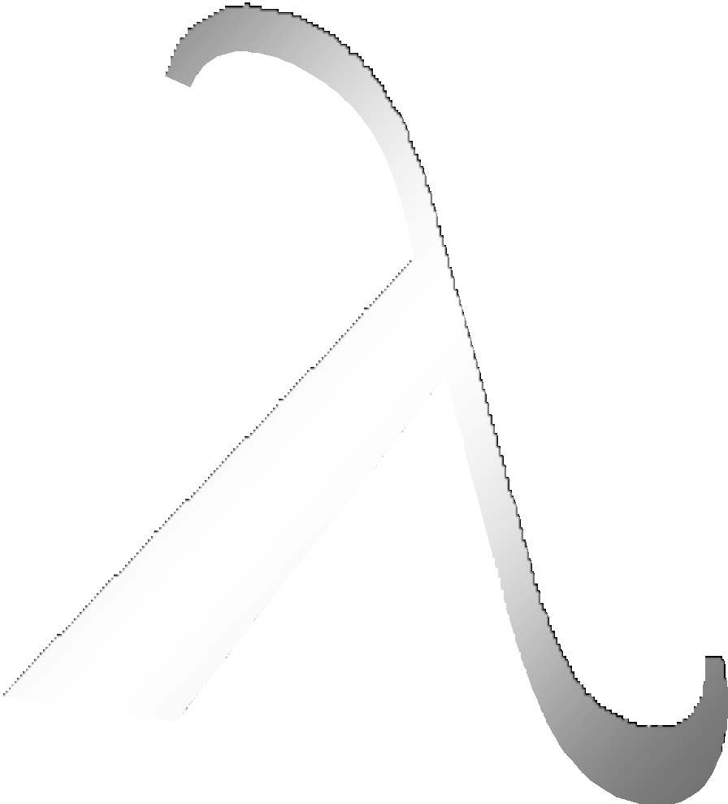

**LAMBDA Factor**

120

100

80

60

Monorail Narrow Gauge

Dual Rail

40

20

0

0

500 1000 1500 2000 2500 3000 3500 4000 4500 5000 5500 6000 6500 7000 7500 8000 8500 9000 9500 10000

Velocity (feet/second)

**1 MARCH 2005**

Distribution A: Approved for public release; distribution unlimited. AAC/PA 07-13-05-270.

|  |  |  |  |  |  |  |  |
| --- | --- | --- | --- | --- | --- | --- | --- |
| **REPORT DOCUMENTATION PAGE** | | | | | | *Form Approved*  *OMB No. 0704-0188* | |
| Public reporting burden for this collection of information is estimated to average 1 hour per response, including the time for reviewing instructions, searching existing data sources, gathering and maintaining the  data needed, and completing and reviewing this collection of information. Send comments regarding this burden estimate or any other aspect of this collection of information, including suggestions for reducing this burden to Department of Defense, Washington Headquarters Services, Directorate for Information Operations and Reports (0704-0188), 1215 Jefferson Davis Highway, Suite 1204, Arlington, VA 22202- 4302. Respondents should be aware that notwithstanding any other provision of law, no person shall be subject to any penalty for failing to comply with a collection of information if it does not display a currently valid OMB control number. **PLEASE DO NOT RETURN YOUR FORM TO THE ABOVE ADDRESS.** | | | | | | | |
| **1. REPORT DATE** *(DD-MM-YYYY)*  1 Mar 2005 | | **2. REPORT TYPE**  Research Summary | | | | **3. DATES COVERED** *(From - To)*  To 01-03-2005 | |
| **4. TITLE AND SUBTITLE**  Holloman High Speed Test Track Design Manual - 1 March 2005 | | | | | | **5a. CONTRACT NUMBER**  N/A | |
| **5b. GRANT NUMBER**  N/A | |
| **5c. PROGRAM ELEMENT NUMBER**  N/A | |
| **6. AUTHOR(S)**  846th Test Squadron | | | | | | **5d. PROJECT NUMBER**  N/A | |
| **5e. TASK NUMBER**  N/A | |
| **5f. WORK UNIT NUMBER**  N/A | |
| **7. PERFORMING ORGANIZATION NAME(S) AND ADDRESS(ES)**  46th Test Group  872 DeZonia Road Bldg 1085 Holloman AFB, NM 88330-7714 | | | | | | **8. PERFORMING ORGANIZATION REPORT**  **NUMBER** | |
| **9. SPONSORING / MONITORING AGENCY NAME(S) AND ADDRESS(ES)**  46th Test Wing  Air Armament Center Eglin AFB, FL 32542 | | | | | | **10. SPONSOR/MONITOR’S ACRONYM(S)**  AAC | |
| **11. SPONSOR/MONITOR’S REPORT**  **NUMBER(S)** | |
| **12. DISTRIBUTION / AVAILABILITY STATEMENT**  Distribution A: Approved for public release; distribution unlimited. AAC/PA 07-13-05-270 | | | | | | | |
| **13. SUPPLEMENTARY NOTES** | | | | | | | |
| **14. ABSTRACT**  Since becoming fully operational, the Global Positioning System (GPS) has consistently proven itself as an effective force enhancer to the US military and its allies. However, because GPS satellites broadcast a signal freely available to the public, commercial applications of GPS outnumber those of the military by a wide margin and are now embedded in applications the original developers of GPS could have never imagined. Among these applications are those used in the United States’ critical national infrastructure, which are becoming increasingly reliant on GPS at an alarming rate.  Unfortunately, over-reliance on GPS for critical applications could leave us vulnerable to future asymmetric attacks. The danger stems from what is well understood in military circles: to function properly, GPS receivers must track low-power satellite signals which are very susceptible to jamming or other interference.  This paper presents a Department of Defense GPS test perspective on civilian GPS vulnerabilities and potential impacts to critical infrastructure, as well as recommends action to mitigate vulnerability exploitation and help protect vital applications. | | | | | | | |
| **15. SUBJECT TERMS** | | | | | | | |
| **16. SECURITY CLASSIFICATION OF:**  **Unclassified** | | | | **17. LIMITATION**  **OF ABSTRACT**  N/A | **18. NUMBER**  **OF PAGES**  5 | | **19a. NAME OF RESPONSIBLE PERSON**  Kevin Dunshee |
| **a. REPORT**  Unclassified | **b. ABSTRACT**  Unclassified | | **c. THIS PAGE**  Unclassified | **19b. TELEPHONE NUMBER** *(include area code)*  (505) 572-1227 |

**Standard Form 298 (Rev. 8-98)**

**Prescribed by ANSI Std. Z39.18**

FOREWORD

The work presented here represents the combined effort of many of the Test Track engineers. In essence we have tried to document the current sled design practices that have lead to successful sled tests. This manual along with more current technical investigations and reports serve as a guide for designing sleds and sled tests. While this design manual provides adequate design guidance for most typical efforts, it can’t cover all the possible scenarios. Because many of our design practices are based on experience rather than purely a scientific approach, the TGTM Flight Chief and senior Track Management take the prerogative to approve deviation from the guidelines stated in this design manual on a case-by-case basis based on their engineering knowledge and vast sled test experience.

TABLE OF CONTENTS

FORWARD 1

TABLE OF CONTENTS 2

LIST OF FIGURES 7

LIST OF TABLES 8

* 1. LOADS AND STRUCTURAL ANALYSIS 9
  2. QSS Loads 9
     1. Thrust and Transmitted Thrust Loads… 9
     2. Aerodynamic Loads 9
        1. Lift (and Side) Loads 9
        2. Drag Loads 10
        3. Aerodynamic Effects of Sled Deflection & Sled Alignment 10
        4. Asymmetric Shock Wave Reflections (Monorail Sleds) 10
     3. Braking Loads 11
        1. Initial Braking Load Factor 11
        2. Reduced Braking Load Factor 11
           1. No Medium Change 11
           2. Medium Change 11
           3. Other Cases 11
     4. Rail Friction 11
     5. Pulldown Loads 11
  3. Dynamic Loads 11
     1. Lambda Loads 12
        1. Calculations 12
        2. History 12
        3. Cautions 12
     2. SIMP Loads 12
     3. Dynamic Analysis and Design System (DADS) 14
  4. Application of Loads 14
  5. Structural Analysis 20
     1. Limit Stress 20
     2. Safety Factor 20
     3. Design Stress 20
     4. Allowable Stress 20
     5. Margin of Safety (MS) 20
  6. GENERAL SLED DESIGN REQUIREMENTS 22
  7. Fatigue 22
  8. Deflection Limits 22
     1. Aerodynamic Deflection 22
     2. Sled Body Deflection 22
     3. Canard Deflection 22
     4. Knifeblade Deflection 22
  9. Natural Frequency Requirements 22
  10. Monorail Sled Roll 23
      1. Sled Roll Defined 23
      2. Sled Roll Geometry 23
      3. Sled Roll Design Requirements 23
  11. Track Strength 23
  12. SLED COMPONENT DESIGN REQUIREMENTS 31
  13. Slippers 31
      1. Geometry 31
         1. Clearance Around Track Hardware 31
         2. Slipper Gaps 31
         3. Web Bearing Slippers 31
      2. Existing Types 31
         1. Full 31
         2. Half 31
         3. Split Full 31
         4. Wrap Around 31
         5. Machined 31
         6. Cast 31
         7. Outrigger 33
         8. Bogie Beams 33
      3. Slipper Wear 33
         1. Design for Bearing Pressure 33
         2. Estimating Slipper Wear 33
      4. Slipper Inserts 33
         1. Insert Uses 33
         2. Insert Protection 35
      5. Design Loads on Slippers 35
         1. Dual Rail Slippers 35
         2. Narrow Gauge Slippers 35
         3. Outrigger Slippers 35
         4. Monorail Slippers 35
      6. Slipper/Rail Gouging… 35
      7. Rotating Slippers 35
  14. Slipper Beams 35
  15. Joint Design 37
      1. Mechanically Fastened Joints 37
         1. Shear Loading 37
            1. Bearing Area 37
            2. Shear Tearout Area 37
            3. Fastener Shear Area 37
         2. Tensile Loading 38
            1. Fastener Tensile Area 38
            2. Head/Nut Pull Through Area 38
         3. Bolt Head to Shank Fillet Clearance 38
         4. Torque Value 38
            1. Tensile Loaded Fasteners 38
            2. Shear and Combined Loaded Fasteners 38
         5. Fastener Hardware 39
         6. Locking Features 39
      2. Adhesives 39
      3. Shims 39
      4. Friction 39
      5. Welds 39
  16. Handling Provisions 39
      1. Sleds 39
      2. Lifting Lugs 39
      3. Threaded Lifting Eyes 40
      4. Hoisting Gear 40
      5. Jacking Gear 40
      6. Towing and Transportation Gear 40
      7. Critical Lifts 40
  17. Rocket Motor Blast on Pusher Sleds 40
      1. Mechanical Damage 40
      2. Thermal Damage 42
  18. Rocket Motor Ejecta Protection 43
  19. Aerodynamic Heating Protection 43
      1. Recovered in Air 43
      2. Not Recovered in Air 44
      3. Helium Atmosphere 44
  20. Propulsion Hardware 44
  21. Equipment Mounts 45
  22. Electrical Conduit 45
  23. Braking 46
      1. Design Rules 46
      2. Operational Rules 46
  24. Knifeblades 46
  25. OTHER DESIGN REQUIREMENTS 48
  26. Helium Bags 48
      1. Setup 48
      2. Diaphragms 48
      3. Wind Limits 48
      4. Clearance to Sled and Hardware 48
  27. Instrumentation 50
      1. Isolation Systems 50
      2. Cable Routing… 50
      3. VMS Head Location and Cabling 50
      4. Umbilical Connection 50
      5. Sensor Adjustment… 50
      6. Igniter Considerations 50
      7. Heat Considerations 50
      8. Shake Testing 51
  28. Track Facility 51
      1. Rail 51
      2. Girder 51
      3. Rail Alignment Criteria 52
  29. Concrete Footings 54
      1. References 54
      2. Loads 54
      3. Factor of Safety 54
      4. Soil Bearing Capacity 54
      5. Maintain Download 54
      6. Concrete Mix Specifications… 55
      7. Concrete Strength 55
      8. Cure Time 55
      9. Materials Testing 55
      10. Reinforcing Bar Joints… 55
      11. Anchor Bolts 55
  30. Screenboxes 55
      1. Definition 55
      2. Backup (Redundant) Screenboxes 56
      3. Screenbox Supports 56
  31. SLED AND TEST DESIGN BEST PRACTICES 57
  32. Cross-Track Wind Limits 57
      1. Monorail Sleds 57
      2. Other Sleds 57
  33. Foams 57
  34. Velocity Measurements 57
      1. Time and Position Systems 57
         1. Space-Position Over Time System (SPOTS) 57
         2. Breakwire System 58
         3. RR-200 Fiber-Optic System 58
         4. Velocity Measuring System (VMS) 58
      2. Photo-Optic Systems 59
  35. Velocity Window 59
  36. Propulsion 59
  37. Sled Design Tips 60

APPENDIX A – SIMP 62

APPENDIX B – ACRONYMS/SPELLING 72/73

APPENDIX C – STANDARD HARDWARE 74

APPENDIX D – DEMONSTRATED CAPABILITIES 75

APPENDIX E – CLIMATOLOGY 76

REFERENCES 78

INDEX 80

LIST OF FIGURES

FIGURE 1.1 – Lambda Factor 13

FIGURE 1.2 – Amplification for Table 1.1 18

FIGURE 1.3 – Amplification for Table 1.3 19

FIGURE 2.1 – Sled Natural Frequencies Demonstrated at HHSTT 27

FIGURE 2.2 – Nominal Slipper Gap 28

FIGURE 2.3 – Nominal Slipper Gap with 0.125” Wear 28

FIGURE 2.4 – Track Static Failure Loads 30

FIGURE 3.1 – Track Hardware 32

FIGURE 3.2 – Slipper Wear Rate 34

FIGURE 3.3 – Gouge Initiation Velocity 36

FIGURE 4.1 – 124” Helium Bag on A Rail Girder 49

FIGURE 4.2 – 184” Helium Bag on B-C Rail Girder 49

FIGURE 4.3 – Rail Geometry 51

FIGURE 4.4 – Girder Cross Section 53

LIST OF TABLES

TABLE 1.1 – Design Condition 1.1 15

TABLE 1.2 – Design Condition 1.2 16

TABLE 1.3 – Design Condition 1.3 17

TABLE 1.4 – Safety Factors 21

TABLE 2.1 – Typical Sled Modes 25

TABLE 2.2 – Measured Track Failure Loads (Static and Dynamic) 29

TABLE 2.3 – Sled Loads Applied To Rail 29

TABLE 5.1 – Spot Coil Sensor Field Configuration 58

TABLE 5.2 – VMS Interrupter Blade Field Configuration 59

TABLE 5.3 – Available Rocket Motors 61

* 1. **LOADS AND STRUCTURAL ANALYSIS.** The design of rocket sleds requires the engineer to evaluate complex loads and numerous load conditions which are imposed on the sleds as they travel along the track. These loads have been divided into two groups based on their duration, and are defined as quasi-steady state (QSS) and dynamic. In this chapter we discuss how to derive loads for rocket sled design, how to apply the loads, and how evaluate the sled’s structural adequacy.
  2. QSS Loads. These are defined as loads due to aerodynamic lift and drag, symmetrical thrust, unsymmetrical thrust, braking, inertial forces in the down track direction, and centripetal loads over the pulldown. Following are discussions of the different QSS loads.
     1. Thrust and Transmitted Thrust Loads. Thrust (T) is defined as the total rocket motor propulsive force for the design condition being analyzed. Transmitted Thrust (TT) is defined as the effective force transmitted from one sled to another sled. Transmitted Thrust has been measured on several sled systems and the measured amplification factor on the quasi-steady state thrust or transmitted varies from 1.3 to 1.5. Tables 1.1, 1.2, and 1.3 show the factors to be used on transmitted thrust for various design conditions. The highest measured oscillatory transmitted thrust normally occurs at burnout of the rocket motors. Transmitted Thrust is the only thrust force that has been measured. The actual thrust at motor attachment locations has not been measured. Consequently, the classic step load factor of 2.0 shall be used in the vicinity of rocket motor attachment. Special definitions referring to thrust and transmitted thrust factors listed on Tables 1.1, 1.2, and 1.3 are as follows:
        1. The thrust factor is applied to total thrust, which includes ignition spike. On-set of thrust shutdown is denoted as the point in time when the thrust or transmitted thrust is a maximum and usually occurs immediately prior to maximum velocity.
        2. The vicinity of the rocket motors is denoted as the attachment hardware, attachment structure, thrust adaptors, and clevises in the immediate area of rocket motor thrust attachment. Also applies for the special case when thrust is transmitted through the aft motor attachment subassembly. It may be necessary to consider structure beyond this area on a case-by-case basis. Use thrust (T) X 2.0 in the vicinity of rocket motor attachment.
     2. Aerodynamic Loads. Aerodynamic data shall be referenced to an ambient static pressure of 12.7 psia, an ambient temperature of 70o F, and a corresponding air density of 0.0020086 slugs/ft3. The corresponding density for helium is 0.0002774 slugs/ft3.
        1. Lift (and Side) Loads. Test Track Engineering must approve use of all aerodynamic lift loads independently determined by non-Test Track organizations. Lift estimates are best obtained from empirical data of configurations similar to the one under investigation. If not available, semi-empirical component build-up methods are generally used (Ref. 1.1). Computational Fluid Dynamics (CFD) analyses are becoming more available, but there has been very little detailed correlation with full scale sled data (Ref. 1.2,1.3,1.4) . Wind tunnel results are available for many sled configurations which can be applied to other configurations with some confidence. Wind tunnel data has been validated with full scale track data to a high degree of confidence for supersonic speeds. Three aerodynamic conditions affecting rocket sled lift, that

are very rarely encountered in free-flight, are: subsonic/transonic ground effect lift on sleds such as the Multi Axis Seat Ejection (MASE) test sled, shock reflections from the ground plane (Ref. 1.6), and the possibility of choked flow under dual rail and narrow gauge sleds (Ref. 1.7).

* + - 1. Drag Loads. Test Track Engineering must approve all aerodynamic drag forces independently determined by non-Test Track organizations. Drag estimates are usually obtained from empirical data of configurations similar to the one under investigation (Ref. 1.5). Otherwise, semi-empirical component build-up methods are generally used (Ref. 1.1). CFD analyses are becoming more common, but Test Track experience shows that caution must be used in interpreting results. CFD drag coefficient estimates are usually lower than actual sled values. Similar concerns apply to wind tunnel data. Wind tunnel drag coefficient estimates are usually lower than actual full scale sled values. There is a rather large body of wind tunnel data available for rocket sleds. This data should be reviewed to see if there have been configurations tested similar to the one under investigation. The aerodynamically-cleaner the actual structure, the closer the correlation is between wind tunnel and sled data. For very aerodynamically-dirty configurations, the actual drag has been measured to be as much as 1.5 times greater than the wind tunnel measured drag. Preliminary drag estimates for sleds in combination or “sled trains” can be made using the *70% Rule* ie., Combined (Drag x Area) = CdAforebody + 0.70 x DdAexposed of the following sled, where Cd is the appropriate drag coefficient for each sled by itself. This can be used sequentially to account for several sleds in a train, starting with the forebody sled and working back. Based on sled frontal areas, this accounts for the development of re-circulation regions that can develop when “blunt “ sleds , typically pusher sleds, are combined with other sleds, effectively streamlining the exposed blunt areas. Aexposed would be the frontal area of a following sled not masked by the forebody sled or sleds. When following sleds are not larger than the forebody sled, increase the forebody drag by 5 to 10 % to account for additional viscous drag of the sled combination.
      2. Aerodynamic Effects of Sled Deflection & Sled Alignment. Effects of sled structural deflection and alignment are especially pronounced in the lateral plane for monorail sleds. Small lateral aerodynamic angles of attack can generate relatively small side loads (and roll moments) that over a significant time duration can cause asymmetrical slipper wear, and thus induce a worsening sled roll condition. This can be catastrophic at high velocity (especially at high Mach numbers in air, where aerodynamic heating and oxidation will make the problem worse). See Section 2.2 for a discussion of sled deflection limits and Appendix F for sled alignment criteria. Vibration isolated test items, especially on monorail sleds, require careful design to avoid serious aerodynamic/structural deflection issues. Dual rail and narrow gauge sleds are usually less susceptible than monorail sleds to these effects. However, there may be cases, such as large payloads attached to isolation systems on dual rail or narrow gauge sleds, where deflection and alignment must be considered.
      3. Asymmetric Shock Wave Reflections (Monorail Sleds). When monorail sleds are operated on B rail, the sled shock waves reflect from C rail, it’s girder, and the narrow gauge trough, back onto the sled. Serious sled roll problems have been experienced on large (Nike) monorail sleds. This problem has been successfully mitigated by filling the narrow gauge trough with water. See Project 42I, Ref. 6.0. Nine inch diameter high speed monorails have been similarly operated without problems. See Project 32I, Ref. 6.0. Transient shock waves bouncing

off girder tiedowns and girder notches, and/or isolated stationary track side structures do not significantly affect sleds probably due to the low impulse of the asymmetric pressure loads created behind reflected shocks on rapidly moving sleds.

* + 1. Braking Loads. All brake structure, brake attachment fixtures and hardware, and sled structure shall be designed using the following load factors.
       1. Initial Braking Load Factor. Due to the step load characteristic of braking loads at entry, a load factor of 2.0 shall be used for brake design.
       2. Reduced Braking Load Factor
          1. No Medium Change. The load factor used for design may be reduced to 1.0 as soon as the steady state loading has been reached as determined by a dynamic analysis.
          2. Medium Change. The technique of Paragraph 1.1.3.2.1 may also be applied to medium changes (i.e. change in density, volume, etc.). Here one would ensure the previous brake load has reached steady state, and use a load factor of 1.0 on that portion of the new brake load. The portion of the new brake load above the previous brake load shall have a load factor of

2.0. Thus, in equation form, the brake design load at a braking medium change is as follows: FBRAKE@CHANGE = FPREVIOUS * 1.0 + (FNEW - FPREVIOUS) * 2.0

* + - * 1. Other Cases. Alternately, when a dynamic loading analysis is not available, a factor of 2.0 shall be used at water brake entry, and linearly taper off to 1.5 at exit of water braking.
    1. Rail Friction. Rail friction is typically a small fraction of other QSS loads and is generally ignored for structural design; but, it is important for performance calculations. However, friction loads resulting from extreme QSS loads or dynamic loads (vertical and lateral) should be considered when designing components in the vicinity of the slippers. These friction loads are typically applied as static loads in structural analysis even though they are actually transient in nature.
    2. Pulldown Loads. Pulldown rail systems are frequently used to divert sleds and sled hardware away from end game activities at the north end of the track. Much discussion has been centered on the matrix of pulldown loads. Currently, required pulldown loads consist of centripetal inertial force, vertical and lateral dynamic loads, aerodynamic loads, thrust and/or transmitted thrust. Note that a sudden change from straight rail to a constant radius pulldown will necessitate using a load amplification factor of 2.0 on the centripetal load. However, a smooth transition (i.e. spiral pulldown configuration) where transition frequency and sled natural frequency are considered can reduce the centripetal load amplification factor to 1.0.
  1. Dynamic Loads. Dynamic loads are defined as inertial forces in the vertical and lateral direction caused by the sled bouncing on the rails. Bouncing may be caused by motor thrust transients, rail roughness and/or oscillating aerodynamics. Realistically, these dynamic loads are

transient in nature but are typically applied statically when analyzing sled structures. Dynamic loads are estimated using one of the following techniques.

* + 1. Lambda Loads
       1. Calculations. The Lambda load is calculated by multiplying the sled weight by the Lambda factor from Figure 1.1. In the vertical direction use 1.0*Lambda load and in the lateral direction use 0.6*Lambda load. The vertical Lambda load and the lateral Lambda load are applied simultaneously either through the center of gravity as a concentrated load or as a distributed load consistent with the sled mass distribution. The Lambda loads are symmetric, i.e. vertical up = vertical down, lateral right = lateral left, and all combinations of these loads must be considered. Note that typically all QSS loads in the lateral direction are symmetric as well as sled structures, and in these cases, only one direction of the lateral Lambda load needs to be considered.
       2. History. The majority of sleds over the past 15 years have been designed using the Lambda dynamic load estimate method. The original Lambda dynamic load estimate was intended to be an initial estimate to obtain rough sizing of slippers, slipper beams, various interfaces, and overall structure. Due to the simplicity of the Lambda method, engineers used the method to estimate final dynamic loads for sled design. This perhaps dangerous leap proved to be successful time and time again to the point that Track engineers felt confident that the Lambda method is sufficient for estimating dynamic loads for design. In addition, as computational power became more and more available, engineers used body loads to apply the Lambda loads instead of the original requirement to apply them as point loads at the center of gravity of the structure being designed. This method has been very successful in designing sleds.
       3. Cautions. Caution should be used when the structure under design is significantly different in configuration to a “typical” sled structure successfully designed using the Lambda method. This “typical” sled configuration might include very stiff (See Section 2.3) monorail sleds with two slippers. If the structure under design varies greatly i.e., a very flexible three slipper sled, the Lambda method should not be used to estimate the dynamic loads and careful thought should be used when deriving dynamic loads. Another example that would necessitate using caution is an unusually stiff narrow-gauge (See Section 2.3) or dual rail sled as these would experience higher dynamic loads than the Lambda method has successfully estimated.
    2. SIMP Loads. At times dynamic loads may need to be more realistically estimated than those estimated when using the Lambda method. Sled Impact Parameter (SIMP) is another technique that can be used to estimate dynamic loads for dual rail sleds. The SIMP technique considers parameters such as sled stiffness (typically well understood for dual rail sleds and not for monorail sleds), load and mass distributions around the sled body, and rail roughness and should provide a more realistic estimation of dynamic loads. Appendix A describes the SIMP dynamic load estimation technique.

**Lambda Factor (g's)**

**FIGURE 1.1 - Lambda Factor**

90



Monorail = 0.0112 X Velocity Narrow Gauge = 0.008 X Velocity Dual Rail

80

70

60

50

40

30

20

10

0

0 1000 2000 3000 4000 5000 6000 7000

**Velocity (feet/second)**

13

* + 1. Dynamic Analysis and Design System (DADS). A third method of estimating dynamic loads is the Dynamic Analysis and Design System (DADS) technique. This technique is usually reserved for very complex or specialized problems or sled designs that require very stringent parameter control such as weight. Due to the complexity of the DADS system and the time involved in generating meaningful dynamic loads, DADS utilization in the normal sled design process is limited. DADS is however an accepted method of estimating vertical and lateral dynamic loads. All DADS analysis must be closely monitored and approved by TGTD. The version of DADS that is used by the Test Track has been modified and verified to simulate the track environment and is not necessarily the same software package as the off-the-shelf package. For this reason, when considering the use of DADS, consultation with TGTD must be accomplished before the load estimation is started.
  1. Application of Loads. The magnitude of the above described loads, and load factors, depends on the point in the trajectory being considered. The point under consideration is referred to as a design condition. The applicable design conditions listed in Tables 1.1, 1.2, and 1.3 and any other condition deemed significant shall be evaluated for hardware tested at the Track. Note that different design conditions may cause concern for different areas of a sled structure. For example, max lift may drive the design of the attachment of a cantilevered nose cone while max velocity may control the sipper design.

TABLE 1.1

**DESIGN OF FOREBODY WITHOUT PROPULSION, DESIGN OF FOREBODY WITH PROPULSION NOT THRUSTING AND DESIGN OF IN-BETWEEN STAGE PUSHER WITH ON-BOARD MOTORS NOT THRUSTING**

|  |  |  |  |
| --- | --- | --- | --- |
| **DESIGN CONDITION** | **QSS LOADS** | **LAMBDA DYNAMIC LOADS** | **SIMP DYNAMIC LOADS** |
| FIRST STAGE THRUST IGNITION | TRANSMITTED THRUST (TT) X 1.5  ACCEL REQUIRED FOR EQUILIBRIUM | VERT = 0 (2)  LATERAL = 0 | VERTICAL = 0 (2)  LATERAL = 0 |
| STAGING | TT X 1.5  LIFT X 1.0 (1)  DRAG X 1.0  ACCELERATION REQUIRED FOR EQUILIBRIUM | VERTICAL = LAMBDA LATERAL = .6 LAMBDA | VERTICAL (3)  LATERAL = VERTICAL X  .6 |
| MAX LIFT | TT X 1.5  LIFT X 1.0 (1)  DRAG X 1.0  ACCEL REQUIRED FOR EQUILIBRIUM | VERTICAL = LAMBDA LATERAL = .6 LAMBDA | VERTICAL (3)  LATERAL = VERTICAL X  .6 |
| ON-SET THRUST SHUTDOWN | SEPARATE DESIGN CONDITON  USE SAME DESIGN FACTORS AS “MAX LIFT” |  |  |
| MAX ACCELERATION | SEPARATE DESIGN CONDITON  USE SAME DESIGN FACTORS AS “MAX LIFT” |  |  |
| COAST OR SUSTAIN (4) | TEST ITEM FORCES TT X 1.5  LIFT X 1.0 (1)  DRAG X 1.0  ACCEL REQUIRED FOR EQUILILBRIUM | VERTICAL = LAMBDA LATERAL = .6 LAMBDA | VERTICAL (3)  LATERAL = VERTICAL X  .6 |
| BRAKING | BRAKING X 2.0  LIFT X 1.0 (1)  DRAG X 1.0  ACCEL REQUIRED FOR EQUILIBRIUM | VERTICAL = LAMBDA LATERAL = .6 LAMBDA | VERTICAL X .6 (3)  LATERAL = VERTICAL X  .36 |

Note:

1. Test Track must approve aerodynamic forces determined independently by contractors.
2. The only slipper dynamic forces considered are couple forces from amplification factors on thrust and transmitted thrust.
3. Use “Propulsion NOT thrusting on-board” curve of Figure A.1, Appendix A.
4. Required for special events such as canopy ejection, seat/man ejection, munitions dispense, and other customer peculiar test events.

TABLE 1.2

**DESIGN OF FOREBODY WITH ON-BOARD PROPULSION THRUSTING AND DESIGN OF PUSHER WITH ON- BOARD PROPULSION THRUSTING (NO FOREBODY)**

|  |  |  |  |
| --- | --- | --- | --- |
| **DESIGN CONDITION** | **QSS LOADS** | **LAMBDA DYNAMIC LOADS** | **SIMP DYNAMIC LOADS** |
| FIRST STAGE THRUST IGNITION (1) | TRANSMITTED THRUST (TT) X 1.7 (7)  ACCEL REQUIRED FOR EQUILIBRIUM | VERT = 0 (4)  LATERAL = 0 | VERTICAL = 0 (4)  LATERAL = 0 |
| STAGING (1) | THRUST = PREVIOUS STAGE Q.S.S. THRUST +  1.7 X THIS STAGE THRUST (7)  LIFT X 1.0 (2)  DRAG X 1.0  ACCELERATION  REQUIRED FOR EQUILIBRIUM | VERTICAL = LAMBDA LATERAL = .6 LAMBDA | VERTICAL (5)  LATERAL = VERTICAL X  .6 |
| MAX LIFT | THRUST X 1.7 (7)  LIFT X 1.0 (2)  DRAG X 1.0  ACCEL REQUIRED FOR EQUILIBRIUM | VERTICAL = LAMBDA LATERAL = .6 LAMBDA | VERTICAL (5)  LATERAL = VERTICAL X  .6 |
| ON-SET THRUST SHUTDOWN | SEPARATE DESIGN CONDITON  USE SAME DESIGN FACTORS AS “MAX LIFT” |  |  |
| MAX ACCELERATION | SEPARATE DESIGN CONDITON  USE SAME DESIGN FACTORS AS “MAX LIFT” |  |  |
| MAX VELOCITY | SEPARATE DESIGN CONDITON  USE SAME DESIGN FACTORS AS “MAX LIFT” |  |  |
| COAST(3) | LIFT X 1.0 (2)  DRAG X 1.0  ACCEL REQUIRED FOR EQUILILBRIUM | VERTICAL = LAMBDA LATERAL = .6 LAMBDA | VERTICAL (6)  LATERAL = VERTICAL X  .6 |
| BRAKING | BRAKING X 2.0  LIFT X 1.0 (2)  DRAG X 1.0  ACCEL REQUIRED FOR EQUILIBRIUM | VERTICAL = LAMBDA LATERAL = .6 LAMBDA | VERTICAL X .6 (6)  LATERAL = VERTICAL X  .36 |

Note:

* 1. Asymmetric Firing. Asymmetric motor firing shall be investigated during these two events using the indicated design factors.
  2. Test Track must approve aerodynamic forces determined independently by contractors.
  3. Required only for “special events” analysis.
  4. The only slipper dynamic forces considered are couple forces from amplification factors on thrust and transmitted thrust.
  5. Use “Propulsion thrusting on-board” curve of Figure A.1, Appendix A.
  6. Use “Propulsion NOT Thrusting on-board” curve of Figure A.1, Appendix A.
  7. A factor of 2 applies in the direct vicinity of rocket motors.

TABLE 1.3

**DESIGN OF PUSHER PROPELLING A FOREBODY**

|  |  |  |  |
| --- | --- | --- | --- |
| **DESIGN CONDITION** | **QSS LOADS** | **LAMBDA DYNAMIC LOADS** | **SIMP DYNAMIC LOADS** |
| FIRST STAGE THRUST IGNITION (1) | THRUST (T) X 1.7 (2)  TRANSMITTED THRUST (TT) X 1.7  ACCEL REQUIRED FOR EQUILIBRIUM | VERT = 0 (5)  LATERAL = 0 | VERTICAL = 0 (5)  LATERAL = 0 |
| STAGING (1) | THRUST = PREVIOUS STAGE Q.S.S. THRUST +  1.7 X THIS STAGE THRUST (2)  LIFT X 1.0 (3)  DRAG X 1.0  ACCELERATION REQUIRED FOR  EQUILIBRIUM | VERTICAL = LAMBDA LATERAL = .6 LAMBDA | VERTICAL (6)  LATERAL = VERTICAL X  .6 |
| MAX LIFT | THRUST X 1.7 (2)  TT X 1.5  LIFT X 1.0 (3)  DRAG X 1.0  ACCEL REQUIRED FOR EQUILIBRIUM | VERTICAL = LAMBDA LATERAL = .6 LAMBDA | VERTICAL (6)  LATERAL = VERTICAL X  .6 |
| ON-SET THRUST SHUTDOWN | SEPARATE DESIGN CONDITON  USE SAME DESIGN FACTORS AS “MAX LIFT” |  |  |
| MAX ACCELERATION | SEPARATE DESIGN CONDITON  USE SAME DESIGN FACTORS AS “MAX LIFT” |  |  |
| COAST(4) | TT X 1.5  LIFT X 1.0 (3)  DRAG X 1.0  ACCEL REQUIRED FOR EQUILILBRIUM | VERTICAL = LAMBDA LATERAL = .6 LAMBDA | VERTICAL (7)  LATERAL = VERTICAL X  .6 |
| BRAKING | TT X 1.5  BRAKING X 2.0  LIFT X 1.0 (3)  DRAG X 1.0  ACCEL REQUIRED FOR EQUILIBRIUM | VERTICAL = LAMBDA LATERAL = .6 LAMBDA | VERTICAL X .6 (7)  LATERAL = VERTICAL X  .36 |

Note:

1. Asymmetric Firing. Asymmetric motor firing shall be investigated during these two events using the indicated design factors.
2. A factor of 2 applies in the direct vicinity of rocket motors.
3. Test Track must approve aerodynamic forces determined independently by contractors.
4. Required only for “special events” analysis.
5. The nly slipper dynamic forces considered are couple forces from amplification factors on thrust and transmitted thrust.
6. Use “Propulsion thrusting on-board” curve of Figure A.1, Appendix A.
7. Use “Propulsion NOT thrusting on-board” curve of Figure A.1, Appendix A.

FIGURE 1.2 - Example of Application of TT Amplification Factor for Table 1.1

### (Determination of Acceleration required for equilibrium)

FBD:

X

FOREBODY SLED

D = 10K

W*gX

TT

Z

Ff Ff

EXAMPLE:

W= 5K

gX = 3.823 (obtained from Velocity Profile Prediction)

∑Fx = W*gX yields (neglecting small friction forces) TT = W*gX + D

TT = (5K) (3.823) + 10K TT = 29.1176K

Acceleration required for equilibrium using a factor of 1.5 on TT

Again applying ∑Fx=W*gX and neglecting the small friction forces yields gX = (TT x 1.5) – D

W

gX = (29.1176K X 1.5) – 10K

5K

gX = 6.735

NOTE: The “acceleration required for equilibrium” for different sleds of the sled train are not necessarily equal due to the applied T and TT amplification factors.

## FIGURE 1.3 - Example of Application of T and TT Amplification Factors for Table 1.3

### (Determination of Acceleration Required for Equilibrium)

FBD:

T = 50K

T = 50K

Pusher Sled

X

TT

D = 25K

W*gX

Z



Ff



Ff

EXAMPLE:

W = 12K

gX = 3.823 (obtained for Velocity Profile Prediction)

∑Fx = W* gX yields (neglecting small friction forces) TT = -W* gX – D + T

TT = -(12K)(3.823) – 25K + 100k TT = 29.1176K

Acceleration required for equilibrium using a factor of 1.5 on TT and 1.7 on thrust Again applying ∑Fx = W* gX and neglecting the small friction forces yields

gX = -(TT X 1.5) – D + (T X 1.7)

W

gX = -(29.1176K X 1.5) – 25K + (100K X 1.7)

12K

gX = 8.44 g’s

NOTE: The “acceleration required for equilibrium” for different sleds of the sled train are not necessarily equal due to the applied T and TT amplification factors.

* 1. STRUCTURAL ANALYSIS
     1. Limit Stress is the maximum stress in a structural member considering all applicable design conditions. Limit stress shall be based on the Distortion-Energy Theory (Henky-von Mises). See Reference 1.8 for discussion. One exception to the Distortion-Energy requirement is the case of bearing stress. For example, a bolt bearing on a plate. In this case, the bearing stress shall be determined and used as the limit stress.
     2. Safety Factor is a factor which the limit stress is multiplied by to account for unknowns in material properties, fabrication quality, dynamic load uncertainty, and degradation in strength that may result from operational usage, handling, and/or outside storage. Safety factors to be used are shown in Table 1.4.
     3. Design Stress is the product of the limit stress in a structural member and the appropriate safety factor.
     4. Allowable Stress is the maximum stress a structural member can withstand without failure based on its material properties. For ductile materials (elongation > 5%), the maximum design stress shall not exceed the allowable stress. Use of brittle materials (elongation < 5%) is not recommended and must be approved by the TGTM Chief. Also note that the allowable stress will need to be adjusted when design for fatigue is considered.
     5. Margin of safety (MS) is the measure of adequacy of a design. All members shall have a positive MS for all design conditions. The MS shall be determined as follows:

MS = (Allowable Stress)/(Design Stress) – 1

#### TABLE 1.4 - SAFETY FACTORS

|  |  |  |  |
| --- | --- | --- | --- |
| **ITEM** | **SAFETY FACTOR** | **ALLOWABLE STRESS** | **COMMENT** |
| SLED COMPONENTS | 1.5 | YIELD | ALL ROCKET SLED COMPONENTS ARE DESIGNED TO THIS  FACTOR UNLESS OTHERWISE SPECIFIED |
| EQUIPMENT MOUNTS | 2.1 | YIELD | BRACKETS, PALLETS, FITTINGS AND ATTACHMENTS USED FOR MOUNTING EQUIPMENT ITEMS TO SLED STRUCTURE  ARE DESIGNED TO THIS FACTOR |
| MECHANICAL JOINTS | 2.1 | YIELD | ALL MECHANICALLY FASTENED JOINTS I.E., BOLTED, RIVETED, SCREWED, BONDED, AND STRUCTURE** IN THE IMMEDIATE AREA OF THE JOINT ARE DESIGNED TO THIS FACTOR, SEE FOLLOWING EXCEPTION |
| BOLTED JOINTS | 1.5 | YIELD | BOLTED JOINTS WITH A SINGLE BOLT OR WITH WELL DEFINED LOADS AND WELL DEFINED LOAD PATHS -  REQUIRES TGTM CHIEF APPROVAL |
| WELEDED JOINTS | 1.5 | YIELD | SINGLE USE SLEDS |
| 2.1 | YIELD | REUSABLE SLEDS |
| JACKING GEAR | 3.0 | YIELD | JACKS, FIXTURES, ATTACHMENTS, STANDS, ETC., USED IN JACKING SLEDS AND/OR SUPPORT EQUIPMENT |
| HOISTING GEAR | 5.0 | YIELD | SLINGS, HOISTING RIGS, SHACKLES, HOOKS, AND OTHER EQUIPMENT USED TO LIFT SLEDS AND/OR SUPPORT  EQUIPMENT ARE DESIGNED TO THIS FACTOR |
| TOWING AND TRANSPORTATION GEAR | 3.0 | YIELD | TOW BARS, TRAILERS, DOLLIES, ETC., USED IN TOWING AND TRANSPORTING SLEDS AND/OR SUPPORT EQUIPMENT ARE DESIGNED TO THIS FACTOR |
| ALL ITEMS LOADED ON PULLDOWN | 1.2 | YIELD | HARDWARE DESIGNED TO GO OVER A PULLDOWN RAIL ARE DESIGNED TO THIS FACTOR |
| ALL ITEMS LOADED  DURING MISFIRE | 1.2 | YIELD | CASES WHERE MISFIRE DRIVES EXTREME LOADING  CONDITIONS - REQUIRES TGTM CHIEF APPROVAL |

\**DESIGN STRESS=SAFETY FACTOR X LIMIT STRESS*

** *STRUCTURE IN THE IMMEDIATE AREA OF THE JOINT IMPLIES STRUCTURE THAT EXPERIENCES THE SAME LOADING AS THE FASTENER.FOR EXAMPLE, WHEN ANALYZING THE HOLE THAT A FASTENER GOES THROUGH THIS SAFETY FACTOR WOULD APPLY TO THE SHEAR, SHEAR TEAROUT, BEARING, TENSILE, AND BOLT HEAD PULL THRU*

21

* 1. **GENERAL SLED DESIGN REQUIREMENTS**
  2. Fatigue. Reusable sleds expected to cost approximately $1M or more must be designed to withstand at least 100 runs. The number of cycles per sled run shall be estimated by multiplying the nominal sled run time by 100 cycles per second if frequency data are not available.
  3. DEFLECTION LIMITS
     1. Aerodynamic Deflection. Sleds with cantilevered or critical aerodynamic sections shall be designed such that the cantilever or critical aerodynamic section does not deflect vertically or laterally more than 1 deg when QSS and dynamic design loads are applied. QSS loads for this analysis shall include the aerodynamic loads resulting from a 1-degree angle of attack. The estimate of the deflection angle shall be determined as the angle between the non-deformed section and the line between the base and the deformed tip of the section. If these limits are exceeded, aerodynamic loads may cause a permanent displacement of the aerodynamic section, which may cause the sled to constantly bear against slipper surfaces. These slipper surfaces may in turn, experience excessive wear to the point of complete failure and loss of the sled.
     2. Sled Body Deflection. Sufficient body stiffness in the design shall be included so as not to allow the sled body to deform, when subjected to QSS and dynamic design loads, such that the slippers will “lock-up” on the rail in the pitch or yaw planes, i.e. slipper gap has been eliminated. This amount of sled body deflection will change the assumed pinned-pinned sled boundary conditions such that structural analysis of the sled is no longer valid.
     3. Canard Deflection. Canards shall be designed such that the deflection due to QSS and dynamic design loads shall not cause the canard to deflect more than 1 degree from the intended design angle.
     4. Knifeblade Deflection. Knifeblades shall be designed such that the knifeblade tip does not deflect more than 1/4 inches when QSS and dynamic design loads are applied.
  4. Natural Frequency Requirements. Sleds shall be designed with the lowest possible natural frequency so as to minimize rail impact loading yet high enough to avoid excessive deflection as noted above. Monorail sled natural frequencies are generally controlled by the free-free modes of the motor or forebody. Note that the motor will be both full and empty of propellant mass during a sled test. Dual rail sled natural frequencies are generally controlled by the slipper beams, and may also have full and empty modes. The natural frequencies shown in Figures 2.1 and 2.2 have been measured or estimated for various sleds tested at the Track. Designers shall strive to stay within these demonstrated frequencies for new sled designs. Sled frequencies deviating more than 15% from those shown in Figures 2.1 and 2.2 are authorized only with consent of the TGTM Chief.
  5. MONORAIL SLED ROLL
     1. Sled Roll Defined. In monorail sled testing, quasi-steady loads in the cross track direction apply a roll moment to the rail because these loads are applied above the location they are reacted, i.e. the railhead. The slippers can only transmit the moment to the rail through a force couple. Each force in this couple starts out as a line contact along the length of the slipper and grows, i.e. widens, as the slipper wears. Depending on factors such as magnitude of the load, duration of the load, length and area of the slippers, etc., the slippers may wear significantly allowing considerable lateral movement in the sled above. This movement, if not allowed for in the sled design, can result in a failed test.
     2. Sled Roll Geometry. Figure 2.2 shows a slipper rolled 2 degrees due to the nominal 0.125” slipper gap and no wear while Figure 2.3 shows a slipper rolled 5.5 degrees due to the nominal 0.125” slipper gap and 0.125” of wear on each wearing surface. Past experience has shown that slipper wear of up to 0.125” is not uncommon for monorail tests; however, test abnormalities have caused more slipper wear and sled roll.
     3. Sled Roll Design Requirements
        1. When contact is required for a successful sled test such as with knifeblades, band cutters, water braking trays, etc., all hardware shall be designed to function properly with a sled roll of up to 6 degrees.
        2. When clearance is required for a successful sled test such as with a sled clearing a screenbox, knifeblades clearing water bags in braking trays, etc., all hardware shall be designed to function properly with a sled roll of up to 6 degrees.
  6. TRACK STRENGTH
     1. Ohio State University (OSU) made theoretical evaluations as well as performed experimental testing to determine strength and other properties of the Holloman Track, see References 2.1 and 2.2. The static and dynamic strength as determined from these References are shown in Table 2.2. Note that the experimental strength testing was performed on a short rail section attached to a concrete girder using a single tiedown fixture identical to those used from TS 5000 to 35000. It is also important to note that the lateral load was applied at the center of the rail head.
     2. Estimated and measured loads applied to the rail during various sled tests are shown in Table 2.3.
     3. Due to the slipper design, lateral loads on the slipper beam of dual rail sleds are never reacted at both rails simultaneously. Instead, both rails react these loads intermittently in a random fashion. The vast majority of dual rail operations, and in all

cases where “half” slippers are used, lateral slipper loads are applied to each rail in the direction away from the center of the sled.

* + 1. For outrigger sleds, the rail above which the main sled body operates takes the lateral loads in both directions.
    2. For monorail sleds, force couples resulting from sled roll must be incorporated into the sled and track analysis.
    3. Sleds shall be designed such that quasi-steady vertical and lateral single point loads do not exceed those shown in Figure 2.4. Note that these loads are generally less than the failure loads determined in Reference 2.2.

TABLE 2.1 – TYPICAL SLED MODES

|  |  |  |  |  |  |  |  |  |
| --- | --- | --- | --- | --- | --- | --- | --- | --- |
| **Sled Type** | **Sled Name (#/project)** | **Weight (lb)** | **Principal Modal Direction** | **1: (Hz)** | **Mode 2:**  **(Hz)** | **3: (Hz)** | **Boundary**  **Condition Notes** | |
| Mono- | KEM (FMN 8911/38I) | 152 | pitch | 32 |  |  | pin-pin | deflection tests |
| rail | Roadrunner Pusher (PMS 9604/46I) | 171 | yaw, torsion | 132 | 252 |  | free-free | modal survey (empty case) |
|  | SM2 DH (FMN 9903/50I) | 1200 | pitch, yaw, torsion | 59 | 60 | 200 | free-free | modal survey |
|  | MMIDAS (FMN 9904/51I) | 236 | ~pitch | 288 | 673 |  | free-free | modal survey (with TM pallet) |
|  |  | 236 | ~yaw | 328 | 678 | 820 | free-free | modal survey (with TM pallet) |
|  |  | 236 | ~torsion | 462 | 819 |  | free-free | modal survey (with TM pallet) |
|  | PAC 3 Long Body (FMN 9701/47I) | 236 | pitch | 49 | 147 | 195 | free-free | modal survey |
|  |  | 236 | yaw | 49 | 214 |  | free-free | modal survey |
|  |  | 236 | torsion | 108 |  |  | free-free | modal survey |
|  |  | 236 | pitch | 191 | 468 |  | fixed-fixed | modal survey |
|  |  | 236 | yaw | 129 |  |  | fixed-fixed | modal survey |
|  | 9" Rain Erosion Sled | 298 | pitch | 101 | 290 |  | free-free | modal survey (empty case) |
|  | (IMS 8812/11Z) | 298 | yaw | 109 | 282 |  | free-free | modal survey (empty case) |
|  |  | 298 | torsion | 239 |  |  | free-free | modal survey (empty case) |
| Narrow | SRR Composite Case | 265 | pitch and yaw, pitch | 146 | 381 |  | free-free | modal survey (empty case, no nozzle or insulation) |
| Gage |  | 265 | torsion | 236 |  |  | free-free | modal survey (empty case, no nozzle or insulation) |
|  | NIKE Over/Under for HUP (80X-A1): |  |  |  |  |  | ~pin-pin | MTI Tech Report -A006 |
|  | NIKE Motor 1st Bending Expended | 1160 | pitch | 82 | 269 |  |  |  |
|  | NIKE Motor 1st Bending Expended | 1160 | yaw | 83 |  |  |  |  |
|  | NIKE Motor 1st Bending Full | 1160 | pitch | 58 |  |  |  | FEA estimate |
|  | Sled Rigid Body Translation Mode | 1160 | pitch | 105 |  |  |  |  |
|  | Sled Rigid Body Translation Mode | 1160 | yaw | 62 |  |  |  | FEA estimate |
|  | Sled Rigid Body Rotation Mode | 1160 | pitch, yaw | 145 | 90 |  |  | FEA estimate |
|  | Simulate 1st Bending | 1160 | pitch, yaw | 61 | 61 |  |  |  |
|  | Slipper Mode | 1160 | lateral translation | 328 |  |  |  | (slipper mass on polyurethane springs) |
|  | TECHNEX (INS 9740/22D) | 5500 | ~pitch plane | 30 |  |  | ~pin-pin | PSDs (27 - 32 Hz) |
|  |  | 5500 | ~yaw plane | 30 |  |  | ~pin-pin | PSDs (approx 30 Hz) |

|  |  |  |  |  |  |
| --- | --- | --- | --- | --- | --- |
| **Sled** |  | **Weight** | TABLE 2.1 - CONTINUED  **Mode**  **Principal Modal 1: 2: 3:**  **Direction (Hz) (Hz) (Hz)**  vertical/pitch 22  vertical/pitch 20.7  pitch 11.5  ~yaw 4  pitch & yaw (@ 45o) 10  payload heave 13  NIKE mtr 1st, 2nd bend 22 24  sled heave 24  payload pitch 27.6 | **Boundary** |  |
| **Type** | **Sled Name (#/project)** | **(lb)** | **Condition** | **Notes** |
| Dual | Ballast Forebody | 40000 | ~pin-pin | PSDs (20 - 25 Hz) |
| Rail | (FDN 8701/76X-C) | 40000 | pin-pin | FEA (including slipper rubber) |
|  | F-22 on MASE (FDN 8505/84E) | 14850 | ~pin-pin | run data |
|  |  | 14850 | ~pin-pin | run data |
|  | F-16 on MASE (FDN 8505/79E) | 14500 | ~pin-pin | run data (approx 10 Hz) and MASE Modal Report |
|  | Ramjet Sled (IDS 8204/19Y-C1) | 7000 | ~pin-pin | assume PSDs (12 - 14 Hz) |
|  |  | 7000 | ~pin-pin | assume PSDs & expended (both in Y (= yaw?)) |
|  |  | 7000 | ~pin-pin | assume PSDs (Belleville washer tuning) (21 - 28 Hz) |
|  |  | 7000 | ~pin-pin | assume PSDs |
| PAC 3 Long Body was configured with three slippers. Ref TGTDD #03-25. 9" Rain Erosion Sled - Ref TGTDD #03-21, pg 12.  NIKE Over/Under for HUP (INS 2004). Ref TGTDD #03-22.  TECHNEX gross weight ~5500 lb (articulating structure, supported mass of forward motor, 3400 lb cantilevered payload [CG 3.5" fwd of front slipper] MASE Sled gross weight 14850 lbs including F-22 fuselage at gross weight ~5200 lbs and CG ~77" forward of mount surface.  MASE Sled gross weight ~14500 lbs including F-16 fuselage and roll mount at gross weight ~3629 lbs and CG ~42" forward of mount surface.  Ramjet Sled (IDS 8204) assume gross weight ~6000 lbs including 800 lb dummy payload on wire rope cable suspension system in pylon. | | | | | |

900

FIG U RE 2 .1 - SLED NATU RAL FR EQ UENCIE S DEM O NSTR ATED AT HHSTT

800



700

M onorail

N arrow G auge

600 Dual Rail

**Fundamental Frequency [Hz]**

500

400

300

200

100

0

0 0 .5 1 1 .5 2 2 .5 3 3 .5 4 4 .5 5 5 .5 6 6 .5 7 7 .5 8 8 .5 9 9 .5 10

**S tru cture G ross W eight [K ips]**

FIGURE 2.2 - NOMINAL SLIPPER GAP = 0.125”

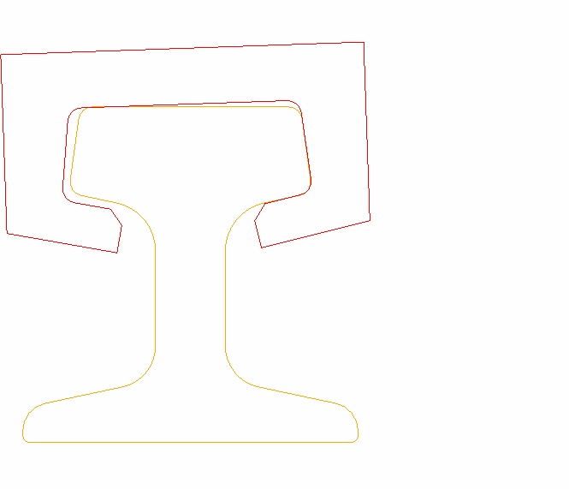

NOTE: Slipper translated laterally to make contact with rail

2 DEGREE ROLL

FIGURE 2.3 - NOMINAL GAP = 0.125”, WEAR = 0.125” EACH SURFACE,

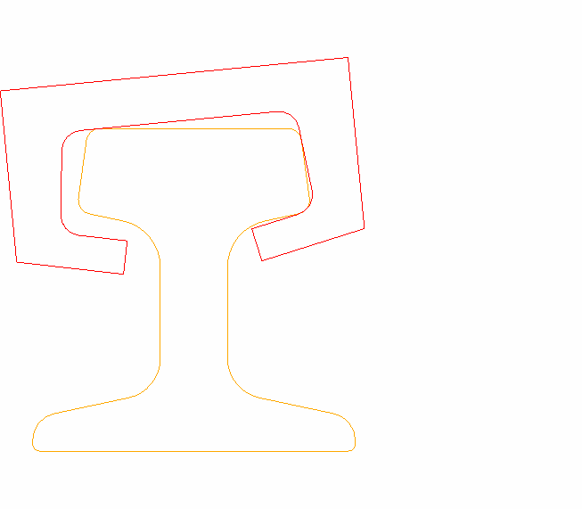

5.5 DEGREE ROLL

NOTE: Slipper translated laterally to make contact with rail

TABLE 2.2 – MEASURED TRACK FAILURE LOADS ON SINGLE TIEDOWN FIXTURE (SIMILAR TO TS 5000 - TS 35000 FIXTURES)

SEE REFERENCE 2.2

|  |  |  |
| --- | --- | --- |
| LOAD DIRECTION/ LOAD TYPE | STATIC | DYNAMIC |
| UP | 80,000 | N/A |
| DOWN | 100,000 * | 175,000 (2 msec) |
| LATERAL | 50,000 | 110,000 (1.5 msec) |

* Calculated Yield Load (4130 Steel @ 125ksi UTS) = 100ksi*0.606in^2*2 = 121kips TABLE 2.3 – SLED LOADS APPLIED TO RAIL

|  |  |  |  |
| --- | --- | --- | --- |
| LOAD DIRECTION/ LOAD TYPE | QSS | DYNAMIC | PROJECT |
| UP LOAD (LB) | 43,000 | 71,000 | B1 Escape (Project 30E, Ref. 6.0) |
| LATERAL LOAD (LB) |  | 48,000 (30 Hz) | B1 Escape (Project 30E, Ref. 6.0) |
| LATERAL LOAD (LB) | 30,000 |  | Cross-Range Rocket |
| LATERAL LOAD (LB) |  | 100,000 (1.2 ms) | Blast Test * (TL G-191) |
| ROLL MOMENT (IN-LB) |  | 1,000,000 ** | NNK (Project 28I, Ref. 6.0) |

* Actually measured

** Calculated Lambda Roll Moment = (5600ft/s)*0.0112*0.6*(1434lb)*18in

**FIGURE 2.4 - HOLLOMAN TRACK STATIC FAILURE LOADS (LATERAL LOADS APPLIED AT CENTER OF RAIL HEAD)**

60.0



TS 35570 to TS 50771 A Rail; TS

30592 to 50771 B Rail; C Rail

TS 5071 to TS 35770 A Rail; TS 5071 to 30592, B Rail

40.0

20.0

0.0

-20.0

**UP AND DOWN LOAD (KIPS)**

-40.0

-60.0

-80.0

-100.0

-120.0

-50 -40 -30 -20 -10 0 10 20 30 40 50

**SIDE LOAD (KIPS)**

* 1. SLED COMPONENT DESIGN REQUIREMENTS
  2. SLIPPERS
     1. Geometry
        1. Slipper Clearance Around Track Hardware. All slipper designs shall provide clearance to preclude interference between slippers and track hardware, taking into account estimated slipper wear and sled roll. See Figure 3.1 for examples of hardware from TS 35000 to the North End on A rail. The most critical clearance in regard to slippers is the top of the vertical tiedown studs located at WL -2.75. Other hardware to be aware of may include screen boxes, camera mirrors, rope braking hardware, etc. Be aware that these items may also interfere with brake probes, knifeblades, canards, gussets, etc.
        2. Slipper Gaps. The ideal slipper gap has been determined to be 0.125 inches based on experience and dynamics modeling. Total vertical and lateral slipper gaps shall be no less than

0.110 inches and no greater than 0.140 inches as measured on the symmetric fitting rail, reference drawing 2001C9010. Reference SOI 10-3.

* + - 1. Web Bearing Slippers. Slipper designs that allow the slipper lips to contact the rail web or the raised lettering on the rail web are not recommended. Designs that require web-bearing slippers require prior approval from the TGTM Flight Chief.
    1. Existing Types of Slippers
       1. Full. Full slippers are one-piece slippers that must be installed at the end of the track and are typically used on dual rail pusher sleds with replaceable inserts. Reference drawing #63- 031-D4.
       2. Half. Half slippers are slippers that wrap around the inside half (typically) of the rail head and are commonly used on ejection forebody sleds with inboard load pads. Reference drawing #63-011-D11 or #83D4911.
       3. Split Full. Split full slippers are similar to the full slippers, but can be installed and removed anywhere on the track. Reference drawing #92E8670.
       4. Wrap Around. Wrap around slippers are bent from plate material and are typically used on slower speed (less than 4,000 ft/s) disposable sleds. Reference drawing #97D43802.
       5. Machined. Machined slippers are machined from one piece or welded halves and are typically used on high-speed disposable sleds or as the housing for reusable sleds. Reference drawing #97D43624 or #2000E8072.
       6. Cast. Cast slippers are slippers made from castings and are typically used as housings for reusable sleds. Reference drawing #95E35805.

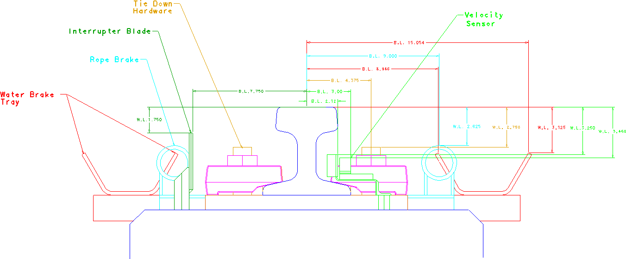

FIGURE 3.1 – Examples of Track Hardware on A Rail (TS 35000 to North End)

32

* + - 1. Outrigger. Outrigger slippers are used to provide roll stability to large monorail sleds. Large monorail sleds that are prone to high levels of roll instability can be fitted with an outrigger structure that spans between two rails (usually between A and B rail) to provide roll stability. In most cases, the outrigger slipper provides roll stability by only reacting vertical loads. The outrigger structure and slipper can be designed to carry additional loads i.e., lateral loads, but the weight and drag penalties are usually too great. Reference drawing #3037D.
      2. Bogie Beams. Bogie beams are used when slipper loads exceed track point load limits, typically on very large heavy sleds. Bogie beams spread the load to multiple slippers. Reference drawing #87D5961.
    1. Slipper Wear. Slipper wear is caused by the sliding contact between the slipper and the rail. At typical sled test velocities, friction between the slipper and the rail causes a thin layer of the slipper to heat. As this thin layer heats, it loses strength until the friction forces are sufficient to remove the layer. Slipper wear also seems to increase with sled velocity although not as directly as with slipper bearing pressure. The pitfalls of slipper wear, i.e. weakening of the slipper and sled roll (see Section 2.4), must be accounted for in the slipper and test designs.
       1. Design for Bearing Pressure. Bearing pressure is defined as the ratio of the QSS load on a slipper/insert to the area of that slipper/insert contacting the rail. The following three criteria shall be met for all slipper/insert designs:
          1. Under normal sled operating conditions, slippers/inserts shall be designed for the following bearing pressure limits and time (t) durations:
          2. Pressure < 300 psi for t > 2.0 seconds
          3. Pressure < 600 psi for t < 2.0 seconds
          4. Lateral slipper/insert bearing pressure during misfire conditions shall meet the following criteria:
          5. Pressure < 1200 psi for 0  t  3.5 seconds
          6. The PV/ ratio is the ratio of the product of bearing pressure (psi) multiplied by sled velocity (fps) to the allowable shear stress (psi) of the slipper/insert material. Under normal test conditions the ratio shall meet the following criteria: PV/ < 10.0.
       2. Estimating Slipper Wear. Occasionally it is necessary to estimate the amount of wear expected during a sled test. Although no precise prediction technique is currently available, there are data available to help designers make a rough estimate. The first method is using wear data from similar sled tests. The second method is using the wear rate chart shown in Figure 3.2 that was based on steady state loads applied over a distance of 2000 feet; see Reference 3.1.
    2. Slipper Inserts
       1. Insert Uses. New slipper designs for reusable sleds shall incorporate replaceable slipper inserts when applicable. Use of slipper inserts at velocities above 4,000 ft/s requires prior approval from the TGTM Flight Chief.

33

**FIGURE 3.2 - Wear Rate as Affected by Various Parameters (Load Application Dist. 2k ft)**

304 Stainless Steel, 2500 fps

304 Stainless Steel-Zinc coat, 2500 fps

Molybdenum, 2500 fps

304 Stainless Steel, 825 fps

304 Stainless Steel-Slaked lime coat, 2500 fps Molybdenum, 825 fps

1.00E-03

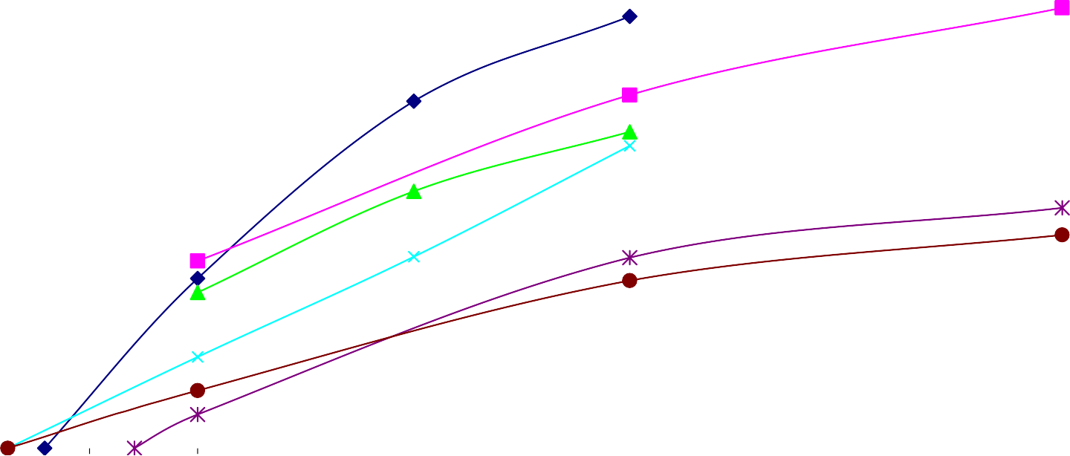

1.00E-04

1.00E-05

1.00E-06

0 150 300 450 600 750 900 1050 1200 1350 1500

**Nominal Bearing Pressure (psi)**



**Wear Rate (in/ft)**

34

* + - 1. Insert Protection. Slipper insert designs shall incorporate tabs on the leading edge of the insert. The tabs should be welded to the slipper insert and provide cover around the leading edge of the slipper housing. This tab protects the reusable slipper housing from rocket motor plume, rail top braking, helium bag plastic, etc.
    1. Design Loads on Slippers
       1. Dual rail slippers shall be designed to transfer vertical and lateral loads from the sled to the rail. The lateral loads on dual rail sleds are to be designed to be transferred from a load pad on the slipper beam, through the inboard side of the slipper, and to the inboard edge of the rail head. Note that all slippers on a dual rail sled transfer vertical loads to the rail; however, the slippers on only one side or the most forward and the most aft slippers on opposite sides transfer lateral loads to the rail. It is desirable that dual rail slippers be designed with isolated slippers and/or isolated load pads.
       2. Narrow gauge slippers shall be designed to transfer vertical and lateral loads from the sled to the rail the same as dual rail slippers with the following exception; lateral loads should be designed to be transferred from the slipper beam, through the outboard side of the slipper, and to the outboard edge of the rail head. The outboard edges are used because these are the aligned railhead surfaces. Vertical and lateral slipper isolation is desirable.

3.1.5.3 Outrigger wing slippers are typically designed to float/slide on a pinned joint in such a way that they do not react lateral loads, i.e. outrigger wing slippers are designed to react vertical loads only. See Paragraph 3.1.2.7.

3.1.5.4. Monorail slippers shall be designed to transfer vertical, lateral, and roll loads from the sled to the rail. This assumes the monorail sled is adequately stiff so as not to allow significant yaw or pitch bending. Note that the force couple at the rail head on the slipper that resists sled roll is typically the dominant load for monorail slipper design.

* + 1. Slipper/Rail Gouging. At velocities above 5000 fps, slippers can gouge the rail during impacts which can be catastrophic since the rail is also simultaneously gouging the slipper. See Figure 3.3 for estimates of the sled velocity at which gouging is initiated for steel slippers impacting a rail coated with red oxide primer. Also see Reference 3.2. The phenomenon that causes rail gouging is the localized slipper/rail impact pressures exceed the strength of both the rail and the slipper materials. Materials with a higher yield strength to density ratio do not gouge until higher velocities are achieved. Sled tests should be designed to prevent rail gouging through the use of appropriate slipper materials and or the application of rail coatings.
    2. Rotating Slippers. All slipper designs that allow rotation shall adhere to the wear criteria of Section 3.1.3. above.
  1. SLIPPER BEAMS
     1. Each end of each slipper beam shall be configured to accommodate standard slipper assemblies when applicable.

35

**Gouging Velcoity (fps)**

**FIGURE 3.3 - Velocity at Initiation of Gouging Versus Compressive Yield Strength For Steel Slippers Impacting a Rail with Red Oxide Primer**

10000



0 mil

3 mil

6 mil

9500

9000

8500

8000

7500

7000

6500

6000

5500

5000

4500

50 100 150 200 250 300 350

**Compressive Yield Strength (ksi)**

36

* + 1. Lateral loads shall be reacted through the slipper assembles in such a manner that variations in track gage are accommodated up to plus or minus 0.10 inches.
    2. An internal conduit of not less than 1.0 inch outside diameter shall be incorporated into the design of each slipper beam. The conduit shall be installed so as to allow electrical wiring bundles of ½ inch diameter to be routed from each slipper hanger to the igniter and/or telemetry compartment.
  1. JOINT DESIGN
     1. Mechanically Fastened Joints
        1. Shear loading shall be evaluated for adequacy in accordance with the following guidelines:
           1. Bearing area shall be determined as the product of the fastener diameter multiplied by the plate thickness. Optimally, the center of fastener holes in parts shall be no closer to the edge of the part than 200% of the fastener diameter and minimally no closer than 150% of the fastener diameter. This distance is typically referred to as edge distance. Edge distances of less that 150% of the fastener diameter shall be handled IAW Reference 3.3 which specifies that the strength be substantiated by adequate testing. Additionally, the thickness of a part with a fastener hole shall be greater than 18% of the fastener hole diameter and cases where it is less shall be handled IAW Reference 3.3. Bearing stress shall be determined as the ratio of shear load to bearing area.
           2. Shear Tearout Area of a fastener through the parts joined shall be evaluated. The shear tear-out area shall be determined as the product of the distance LST as shown below multiplied by the part thickness multiplied by 2. Shear stress shall be determined as the ratio of shear load to shear tear-out area.



LST

40o

* + - * 1. Fastener Shear Area. Fastener shear strength is typically reported based on shank area. Certain designs may require the fastener threads to be in the shear plane and in such cases, the reported strength is not applicable. Shear area through the threads shall be determined based on the nominal minor diameter of the threaded section. Fastener shear stress shall be determined as the ratio of the shear load to the fastener shear area.
      1. Tensile Loading shall be evaluated for adequacy in accordance with the following guidelines:
         1. Fastener Tensile Area. Fastener tensile strength is typically reported based on the area of the nominal minor diameter. Fastener tensile stress shall be determined as the ratio of tensile load to fastener tensile area.
         2. Head/nut pull through area shall be determined as the product of the fastener head/nut perimeter multiplied by the part thickness. Pull through shear stress shall be determined as the ratio to the tensile load to the pull through area.
      2. Bolt head to shank fillet clearance. High strength protruding head bolt designs include a radius under the bolt head to reduce the stress concentration. Provide clearance of this bolt head radius by a chamfered feature in the part design and/or through the use of a chamfered washer.
      3. Torque value for all fasteners shall be specified on all engineering drawings. Torque value (T) is related to fastener preload (P) through the equation T=P*K*D where K is the “nut factor” and D is the nominal shank diameter. The mean value of K for non-lubricated steel fasteners is 0.2 and is dimensionless. The value of K for other applications must be determined experimentally; however, sources such as Reference 3.4 provide measured K values for various applications. Torque value as used in this section is meant to be above the running torque, i.e. the torque to overcome the resistance during installation and before seating of the fastener.
         1. Tensile Loaded Fasteners. Preloading fasteners designed for tension applications to a value slightly greater than the limit load, eliminates joint gapping and reduces the cyclic loading fatigue effect. However, it should be noted that the load in the fastener will always exceed the preload when loads are applied to the joint. One of the following two methods of determining preload shall be used.

Method 1. Set the preload level at 70% of the allowable fastener load, i.e. yield load with appropriate safety factor.

Method 2. When a preload level greater than that as determined by method 1 is desired, a detailed joint analysis shall be performed. Reference 3.4 has example calculations. Alternatively, an FEA may be used to evaluate the joint. In either case, the preload shall be set to a level such that the allowable fastener load is not exceeded when design loads are applied to the joint.

3.3.1.4.2. Shear and Combined Loaded Fasteners. Fasteners loaded in shear alone, or in combined shear and tension, shall be preloaded to a value not to exceed 5% of the allowable fastener tensile load. In cases where more preload is needed/required, a detailed analysis of the joint in service shall be performed considering all loads. The following interaction formula shall be used to evaluate the adequacy of a fastener in combined shear and tension loading: RS3 + R 2

T

 1.0, where RS and RT are ratios of the design load to the allowable load in shear and tension, respectively. See Reference 3.3.

* + - 1. Fastener Hardware. Aircraft-quality NAS, AN, and MS fastener hardware shall be used for all Track applications. Variations are allowed on a case-by-case basis and must be approved by the TGTM Flight Chief. For more information see SOI 10-11.
      2. Locking Features. All bolts, screws, and other threaded fasteners shall be safetied, either by safety wire, lock nuts (excluding those using nylon, fiber, etc.), other approved methods, or a combination of methods. Threaded fasteners shall protrude a minimum of two full threads beyond lock nuts. The useful life of locking mechanisms, i.e. the number of times a locking mechanism can be installed and still function properly, is typically limited and shall exceed the expected number of uses. All joints with a single point of failure, i.e. those where loss of a single bolt would yield catastrophic results, shall have redundant locking mechanisms. Adhesives, e.g. Locktite, may be used as a secondary locking mechanism for this class of joints that are not planned to be reusable. Upon approval from the TGTM Flight Chief, adhesives may be used as the primary locking mechanism for less critical joints if no other method is available.
    1. Adhesives. Adhesive capability, i.e. bond strength, is rarely if ever qualified in a high vibration environment and thus shall not be used to create joints used in sled testing. However, as noted above, adhesives may be used as a locking mechanism. The TGTM Flight Chief must approve variations from this policy. See Projects 57I and 58I, Ref. 6.0, for examples of past failures using adhesives.
    2. Shims. The use of shims is allowed in sled fabrication typically to attain the desired sled alignment. However, all shims must be welded, mechanically fastened or captivated such that their ability to vibrate free is eliminated IAW SOI 10-2.
    3. Friction. The use of friction in joint design is not allowed due to the high vibration environment of sled testing and past failures. See Project 57I, Ref. 6.0, for an example of a past failure where the designer relied on friction.
    4. Welds. Welding procedures as outlined in Reference 3.5 and SOI 10-7 shall be followed.
  1. HANDLEING PROVISIONS
     1. Sleds shall be capable of being lifted in the maximum gross weight configuration (and all other operational configurations) taking into account out-of-balance conditions, sling leg angles and CG location. Specify standard slings and shackles when possible. Unique lifting and handling processes require approved designs and procedures.
     2. Lifting lugs shall be provided in sufficient quantity and at the proper locations for the sled to be lifted in the maximum gross weight condition in a level attitude. Lifting lugs shall be designed so the proper shackles must be used when handling the sled and sized appropriately to preclude the use of undersized shackles. All lifting lugs and associated hardware, including the attachment points on the sled, shall be designed in accordance with Paragraph 3.4.4. Rigid lifting lugs shall account for lateral or bending loads induced by swing, out-of-balance conditions, and sling leg angles.
     3. Threaded lifting eyes (eyebolt or hoist eyes) are **NOT** permitted under any conditions. Swivel hoist rings (e.g. Carr Lane “Swivel Hoist Ring”) are recommended.
     4. Hoisting gear are slings, chains, hoisting rigs, spreader bars, shackles, hooks, and other equipment used to lift sleds and/or support equipment. These items are designed to a minimum safety factor of 5.0 (safe working load is < 20% of the minimum calculated yield load of the weakest component). Reference MIL-STD-1365B. All slings, hoisting rigs, and spreader bars shall be proof tested to 200% of their rated capacity as per SOI 91-18.
     5. Jacking gear is jacks, fixtures, attachments, stands, etc. used in handling sleds and/or support equipment. These items are designed to a minimum safety factor of 3.0 (safe working load is < 33% of the minimum calculated yield load of the weakest component). Reference MIL-STD-1365B. All munitions stands shall be proof tested to 200% of their rated capacity as per SOI 91-18.
     6. Towing and transportation gear are tow bars, trailers, dollies, etc. used in towing and transporting sleds and/or support equipment. These items are designed to a minimum safety factor of 3.0 (safe working load is < 33% of the minimum calculated yield load of the weakest component). All munitions trailers shall be proof tested to 50% of their rated capacity as per SOI 91-18.

Design and Testing Requirements

|  |  |  |
| --- | --- | --- |
| Type of Equipment | Safety Factor To Yield | Proof Test of Rated Load |
| Sling | 5.0 | 200% |
| Hoisting rigs | 5.0 | 200% |
| Spreader bars | 5.0 | 200% |
| Munitions Stands | 3.0 | 200% |
| Munitions Trailers | 3.0 | 50% |

Reference: MIL-STD-1365B & SOI 91-18

* + 1. Critical lifts are defined as: Total load weight exceeds 75% of rated capacity of hoist, load is of unusual shape and center of gravity is not determined, load requires an additional hoist to help balance, turn, or invert load, load contents contain pressurized or hazardous substances, lifts of high value or consequence that would affect or delay project/experiment, lifts that tilt up or down requiring multi-functions simultaneously, lifts that are liquid filled (full or partial) where the weight can shift, lifts that are near power lines, lifts that are submerged or part submerged. If any of these criteria is met, SOI 91-19 must be strictly followed.
  1. ROCKET MOTOR BLAST ON PUSHER SLEDS
     1. Mechanical damage is an over-pressure phenomenon due to the mass flow and velocity of the exhaust plume, similar to a body being subjected to free stream atmosphere at high velocities.

The over-pressure phenomenon can be accounted for by designing the applicable portions of the pusher structure to sustain the design pressure derived from the following relationship:

P = Cd x q

Where:

P = Design Pressure

Cd = Drag coefficient of the pusher sled surface on which the design pressure (P) acts.

q = (k/2 Pp Mp2), or dynamic pressure in the motor plume (nozzle exit, or where plume pressure expands to ambient pressure).

And where:

k = Gas constant for the rocket motor exhaust plume

Pp = Static pressure in the upper stage rocket motor exhaust plume (nozzle exit, or where plume pressure expands to ambient pressure).

Mp = Mach Number in the upper stage rocket motor exhaust plume (nozzle exit, or where plume pressure expands to ambient pressure).

Also:

Tp = Static temperature in the upper stage rocket motor exhaust plume (nozzle exit, or where plume pressure expands to ambient pressure).

Use the properties listed below for the following rocket motors:

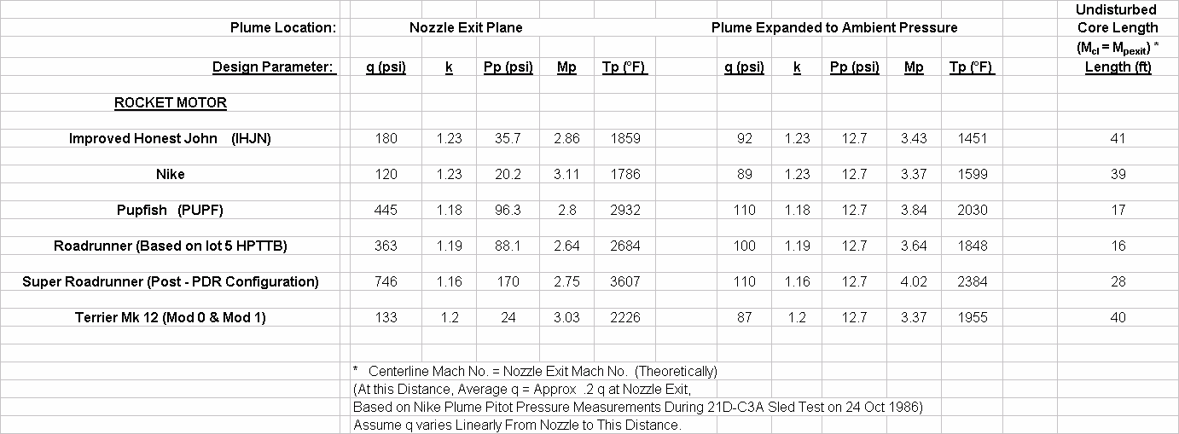

Undisturbed Core of Supersonic Flow Plume Mixing Region

* + 1. Thermal damage is caused by uneven, high, heating rates and appears as warping of plate sections and bending of tubular sections. Chemical damage is closely related to thermal damage and manifests as surface erosion and pitting of exposed surfaces. Damage due to thermal and chemical effects can be alleviated by application of the following practical design criteria:
       1. Use high temperature, erosion resistant, materials such as stainless steel and 4XXX series steel rather than aluminum or other “aircraft” type materials.
       2. Protect major structural members and rocket motor attachments with heat shields. Experience has shown that caps and stand-offs of 0.18 to 0.25 inch thick stainless steel are quite successful, but that “sacrificial” materials like aluminum, phenolic and other plastics, and spray- on or trowel-on ablatives are unsatisfactory for use on large dual rail pusher sleds.
       3. Allow for thermal expansion of nonstructural members such as access panels by the use of techniques such as slotted bolt holes.
       4. Exposed nuts, bolts, and similar hardware should be shielded by structure. If this condition is not possible, expose the bolt head end rather than the threaded end.
       5. Avoid large flat plate areas. If a large flat plate area is unavoidable, the area should be swept or placed at an angle to the oncoming flow and must be designed to withstand without damage the large over-pressure and instantaneous high heating rates.
       6. Avoid “pockets” in the structure, such as the convergence of several structural tubes, which would tend to funnel the high temperature gasses onto one spot.
       7. Avoid sharp edges and angled projections. Such edges tend to erode faster than rounded edges.
       8. Monorail Sleds and Narrow Gauge Sleds. For both throw away and reusable monorail and high performance narrow gauge sleds, it is normally most expedient to use flat push-pads, as it is usually desirable to create as much aerodynamic drag as possible after staging. Common practice is to use bolt on aluminum push-pads, often protected by phenolic and/or spray-on or trowel-able ablative materials. Attaching bolts should have counter sink heads or there should be counter bores for normal bolt heads, and the bolt heads should be protected by ablative material. It may be found necessary to protect some push-pad attachment structures, slipper

beams, drag plates, and front slipper leading edges with ablative materials where there is direct plume impingement from the upper stage. High performance rocket motors with aluminized propellant like the Pupfish, Roadrunner, and Super Roadrunner create much more thermal and chemical damage than double-base propellant motors such as the Nike and IHJN.

* 1. Rocket Motor Ejecta Protection. Rocket motors on high speed sleds have failed structurally due to particles, or molten metal, coming from the front of sleds. The most common source of these ejecta is the front slipper, especially in severe sled roll conditions. See Mission 17A – B1, Ref. 6.0. Another source of ejecta is paint chips loosened by the front slipper. See Project 49I, Ref. 6.0. Teflon sheets and/or ablative cork are required to protect the underside of rocket motors traveling above 3,000 feet/sec when ejecta are possible.
  2. AERODYNAMIC HEATING PROTECTION
     1. Recovered In Air. The most severe aerodynamic heating environment for rocket sleds is the case where a hypersonic sled is run completely in air, then recovered on track. This combines a heating rate problem with a heat load problem. Also, extremely severe heating occurs behind shock interactions. Heat transfer coefficients can be several times those in neighboring areas where there are no shock interactions. Following are rules of thumb for thermal protection.
        1. Bare steel will rarely have serious heating problems up to approximately M∞ = 3.9.
        2. Use flame sprayed Eutalloy Tungsten on steel in stagnation regions and shock interaction regions for M∞ > 5.0.
        3. Bare aluminum should have no serious heating problems up to approximately M∞ = 2.7, except possibly in stagnation regions.
        4. Protect aluminum in stagnation and non-stagnation regions for M∞ > 3.4.
        5. One part high temperature RTV 732 with a thickness between 0.13” and 0.19” protects up to approximately M∞ = 3.5, limited by stagnation regions.
        6. Two part high temperature RTV 560 with a thickness between 0.13” and 0.19”protects up to about M∞ = 4.6, limited by stagnation regions.
        7. Chartec with a thickness of 0.19”protects steel up to at least M∞ = 5.1 and aluminum up to at least M∞ = 4.0 for most purposes.
        8. Flame sprayed ceramic coatings are useful for steel at M∞ > 4.5, in combination with other thermal protection materials at the higher speeds.
        9. Flame sprayed ceramic coatings are useful for aluminum up to at least M∞ = 4.5 (non – stagnation regions).
        10. Cork (~0.06”), Teflon (~0.13”), or Chartec (~0.13”) should be used to protect steel rocket motor cases above approximately M∞ = 5.4. Composite motor cases require protection at lower speed.
        11. Above approximately M∞ = 5.9, recovered sleds need at least glass phenolic in high heating regions, and reinforced carbon-carbon (RCC) in stagnation and shock interaction regions. Steel protected by Eutalloy tungsten begins to erode rapidly in stagnation regions at these speeds.
     2. Non-recovered in Air. Sleds that run completely in air, but are not recovered on track may still be exposed to very high heating rates, but their thermal protection requirements are some what reduced by the short duration of the very high speed. At M∞ > 5.9, the extremely high temperatures reached may still require at least glass phenolic and RCC for sled protection because the heating is so severe in stagnation and shock interaction regions.
     3. Helium Atmosphere. A helium atmosphere creates a much more benign heating environment as compared to air at an equivalent ground speed. In addition to a lower Mach #, the facts that helium is inert, and is not an oxidizing atmosphere, help even more. Note that a sled using a helium atmosphere may reach very high Mach numbers in air before or after the helium section. At high speeds, severe heating damage can occur in less than ½ second, so thermal protection may still be required.
  3. PROPULSION HARDWARE
     1. Motor mounting provisions shall be designed to permit easy loading of the motor(s) by use of an overhead crane.
     2. Motor mount(s), attachments, and sled structure shall be designed to allow for a total longitudinal motor case expansion of 0.25 inch.
     3. Motor case(s) may be used as a structural member.
     4. No structure shall extend aft of the rear nozzle exit plane except for the water brake and push pad structure, if mounted on the aft beam of dual rail sleds. In cases where water brake or push pad structure do extend aft of the nozzle exit plane, thermal effects must be well understood and accounted for.
     5. Forward Motor Mounting
        1. All forward motor mounting fitting(s) on dual rail sleds shall be designed to eliminate or minimize bending moments induced in the motor case(s) due to the sled structural deformation or dynamic loads during all operating conditions.
        2. The motor case(s) shall be investigated to insure that it is capable of sustaining induced moments within specified material strength margins of the motor case(s).
     6. Aft Motor Mounting
        1. All aft motor supports shall accommodate 0.25 inch thermal growth in motor case length.
        2. The aft motor support(s) shall permit the motor to be lowed vertically into the mount using an overhead crane.
     7. Misfire Conditions. Sleds, when operating with motors, shall be designed to sustain, without structural damage, asymmetric loadings due to all possible misfire motor combinations.
  4. Equipment Mounts. Brackets, pallets, fittings, and attachments used for mounting equipment items to the sled structure shall be designed using a safety factor of 2.25. See Table 1.4.
  5. Electrical Conduit. Design of required conduit runs shall be in accordance with the following guidelines to preclude both fracturing of the conduit and rattling of loose parts which can mask accelerometer data during checkout testing.
     1. Conduit routed parallel to skin panels shall not be closer than ¼”. In no case shall it be in parallel contact with any member or skin panel.
     2. For conduit runs inside beams and other parts subject to significant flexure, conduit shall be located near the neutral axis to minimize induced stresses in the conduit. When this is not possible supports shall be provided which allow flexure along the major strain axis.
     3. The first bending mode frequency of all unsupported spans should be above 70 Hz. The preferred method of joining sections is by use of short close-fitting external sleeves welded on both ends to the outside of the conduit. The conduit shall be fully chamfered internally prior to joining. Ends of the conduit shall meet within .060 inches inside the sleeve.
     4. The preferred method of penetrating bulkheads is to pass the conduit through an over- size hole, supported by a clip welded both to the conduit and to the bulkhead. Flexibility to the clip is determined by the needs of the location.
     5. Penetration through an outer skin shall be welded all around to prevent entry of braking water and debris.
     6. Penetration through very thick outer surfaces (greater than 5 times the conduit wall thickness) should use an intermediate thickness collar to prevent burn through of the conduit due to thick-thin welded joint problems.
     7. Conduit sizes one inch ID and less shall be fabricated from stainless steel hydraulic tubing. Sizes over one inch may be electrical grade rigid conduit. Thinwall electro-mechanical tubing (EMT) shall be used only with specific approval of the Test Track.
     8. All bend radii shall be greater than six inches. Flattening of bends shall be less than one- tenth of the conduit diameter.
     9. Pull-boxes with sealed covers shall be used at junctions and locations where six inch bend radii are not possible.
  6. BRAKING
     1. Brake Design
        1. If a probe system is used it shall have a tapered wedge shape.
        2. The brake, and any fixtures in the vicinity of the brake, shall be located as far aft on dual rail pushers as is practicable, and shall be designed to minimize damaging spray impingement on the mission sled(s), sled structure, rocket motors, and/or Test Track facility.
        3. For dual rail sleds, the brake tip(s) shall be designed to set no lower than WL -17 due to the trough geometry between TS 0 and 5071. For narrow gage sleds, the brake tip(s) shall be designed to set no lower than WL -17 when the sled will be operated north of TS 35570. Narrow gauge sleds will have no trough brake when operated south of TS 35570.
     2. Brake Operation
        1. Do not use scoop braking above 1000 ft/sec due to the unknown flow characteristics of the water/air system in this operational condition.
        2. Monorail sled braking entrance velocities above 1000 ft/sec require the use of split braking medium areas in order to minimize the cross track forces. See Reference 3.6.
  7. KNIFEBLADES
     1. Knifeblades are steel blades mounted on board sleds to transfer electrical energy from trackside screenboxes to an event. These knifeblades physically cut through the screen mounted on the screenbox to make electrical contact. Two knifeblades and two screenboxes are used to complete each circuit. Note they need to be electrically isolated from the sled structure to which they are mounted.
     2. The leading edges of knifeblades are typically rounded or wedged as well as swept back for drag reduction. For high-speed tests in air, the leading edge may need Eutalloy tungsten for thermal protection. Note that other thermal protection materials have not been proven to adequately meet the electrical conductivity requirements of knifeblades.
     3. Knifeblade installations shall be designed to keep the knifeblade assemblies as close to the rail as possible. Multiple knifeblades used to stage propulsion ignition or any other event should be arranged so that progressive events are controlled by knifeblades, which are progressively closer to the rail. This is very important for monorail sleds as knifeblade

movement resulting from sled roll is proportional to the distance from the rail. If the stack of knifeblades becomes to high, this progression can be accomplished by going from long to short knifeblades and using foam inserts to obtain the screenbox bracket clearance. Of the two methods, the former is more desirable.

* + 1. Mixtures of knifeblades for both propulsive and test item events on the same bracket shall be avoided. Whenever possible, brackets for propulsive and test item events will be segregated on opposite sides of the sled.
    2. Separation between knifeblades should be maximized where possible. Separation between knifeblades for a single event should ideally be in multiples of one inch with a minimum separation of four inches.
    3. Common grounds on a single knifeblade assembly should be avoided unless the stack of blades is excessive.
    4. Dual rail specifics
       1. Mount propulsion ignition knifeblades on the right side (rear view) of the sled.
       2. Mount test event knifeblades on the left side (rear view) of the sled.
    5. Outrigger specifics
       1. Configuration of outrigger sleds will require placing all knifeblade brackets on the side opposite the wing of the main body. The outrigger slipper assembly should not be used for knifeblades.
       2. In some instances, low mounted knifeblades could be used on each side of the main sled body, similar to a monorail sled.
    6. Monorail Specifics. Whenever practical, a knifeblade used for staging should be mounted on the sled carrying that propulsion near the igniter position.
    7. Knifeblade identified as #1 on dual rail and outrigger sleds should be level with the top of the rail. Where polarity is called out for knifeblades, the lower blade will be the negative or ground, and the upper blade will be positive.
  1. OTHER DESIGN REQUIREMENTS
  2. HELIUM BAGS
     1. Setup. Helium bags are use on some monorail and narrow gauge sled tests to increase velocity and to reduce aero and aero-thermal effects on the sleds. A four mil plastic sheet is draped over the rail and sealed with a spline system on the sides of the girder approximately 14 inches below water line zero. Four mil plastic is also used as end caps and for internal diaphragms on longer bags. Bag material is not usually kept in stock and is a special order item. Rolls of plastic sheet, typically 1000-ft length, can be ordered in several widths but the current draping frames for A-rail and BC-rail installation are limited. Note that six to eight inches of the width on each side is used as a skirt below the spline seal.
     2. Diaphragms. Diaphragms are recommended on long helium bags to insure that potential problems are isolated to a relatively short section of the bag. Should the helium bags ability to hold the required pressure become inadequate, a helium bag with several sections will be much quicker to bring back online than the entire bag.
     3. Wind Limits. Current crosswind limits due to bag movement and clearances are restricted to 5 knots if the internal bag pressure is above 0.2 inches of water and 3 knots if the pressure is less than this.
     4. Clearance to Sled and Hardware. Care must be taken to allow adequate clearance between the bag profile and parts of the sled including knifeblades, antennas, fins, etc. Because of wrinkles in the bag and motion due to wind, there should be a minimum clearance of 10 inches on top and 10 inches on each side. Figures 4.1 and 4.2 are examples of bag profiles for the monorail and narrow gauge rail setups respectively. Notice that the shape is oblong and not circular. Theses dimensions will also change somewhat depending on the pressure inside the bag.

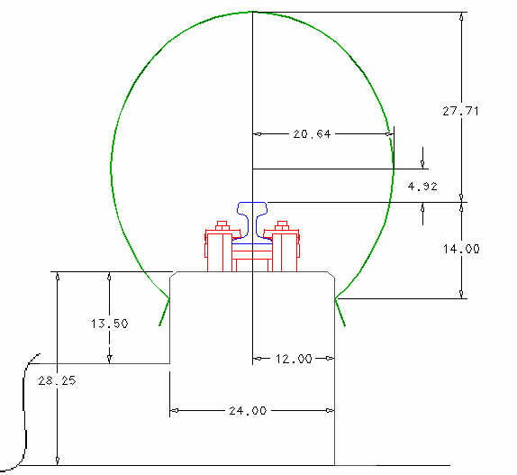

FIGURE 4.1 - 124” Bag on A Rail Girder

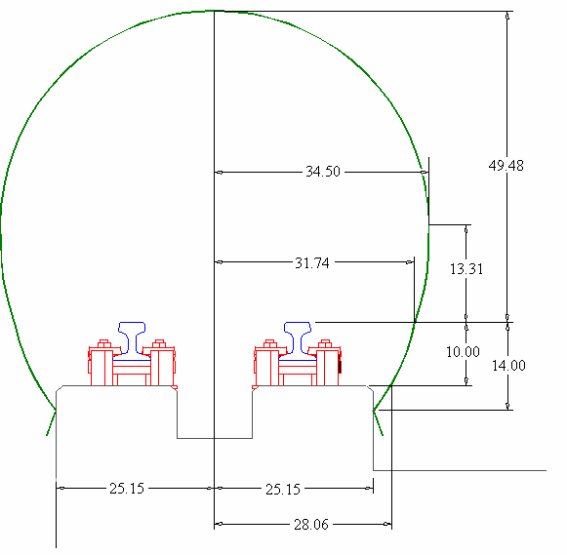

FIGURE 4.2 - 184” Bag on B-C Rail Girder

* 1. INSTRUMENTATION
     1. Isolation Systems. Instrumentation packages require 3-axis isolation. Simple foam isolation designs using several densities of foam ranging from 1 lb/ft3 to 10 lb/ft3 have been highly successful. Foam isolated cruciform pallets, e.g. drawings X97E43969 and X97E43993, used in 9-inch monorail sleds require a roll-restricting feature to insure system integrity throughout the test. In addition to foam isolation, wire rope isolators and elastomer cupmount isolators have also successfully been employed. Isolated pallets must have enough room to move without banging against antenna connectors, pull away connectors, or other structure.
     2. Cable Routing. Accommodations for sensor cables need to be considered as part of the sled design. When possible, cables should be routed through conduit. Otherwise, cables should be well protected from the high vibration/thermal/windblast environment typically experienced on sled tests. Wire cable runs must have enough slack for all potential movement between the isolated pallet and the hard point terminations. Strain relief must be provided along cable runs to insure the cables remain in place during the harsh rides and can withstand pull away forces when connectors are required to be separated. Cables passing through different chambers of the sled should be protected from chafing. Ideally, all telemetry components and sensors should have access ports that allow a clear view of the connectors. It is undesirable to route sensor wires in close proximity to antenna cabling as the RF can be induced into the system electronics causing measurement errors.
     3. VMS Head Location and Cabling. The VMS head(s) needs to be mounted at the appropriate height and distance from the sled body. VMS wiring is typically routed through conduit to the instrumentation pallet. The wires need to be routed such that they are not alongside any transmitting or high frequency signal cables. For new sleds, both port and starboard VMS locations should be considered to accommodate fixed interrupter locations along the track.
     4. Umbilical Connection. Consideration must be given to the location of the instrumentation umbilical connection and the method of pull away. The method of pull away (mechanized or separation by sled motion) needs to be decided upon as part of the sled design.
     5. Sensor Adjustment. Some measurements (strain gages in particular) may require that the sensor be balanced just prior to the mission. To insure accurate measurement resolution, every effort should be made to provide access to R-Cal boxes in this situation.
     6. Igniter Considerations. All antenna components, transmitters and antenna cables must be located at least 8 inches from any igniter or igniter cabling to insure that RF energy is not introduced into the igniters. Otherwise, measures such as energy calculations and/or testing shall be performed to insure the configuration is deemed safe.
     7. Heat Considerations. All electronics generate heat which must be dissipated or, alternatively, restrictions placed on the operation time of the instrumentation. Transmitter powered time may be quite limited in small compact sleds, i.e. 3-5 minutes. The transmitters are typically limited to 170 degrees F, above which, they will shut down. Thermal heating from pre-

mission testing may not dissipate before launch depending on the time lapse and how the pallet is installed in the sled, e.g. packed in foam. A small tube to provide a flow of nitrogen for cooling can resolve this situation.

* + 1. Shake Testing. Instrumentation packages must be shake tested, e.g. in the 746 TS environmental lab, before sled testing. Typically, the shaker table cannot replicate the sled environment, but the tests insure the systems do not have any major shortcomings. Shake tests must include both random and sine sweep passes applied in all three directions.

4.2. TRACK FACILITY

* + 1. Rail. The rail is 171 pound per linear yard crane rail continuously welded along the entire length of the track. Figure 4.3 shows the rail geometry used to design slippers. Note that due to different mill runs of rail from 1954 to 2000, dimensional tolerances vary from stick to stick as much as 0.25 inches. The crown of the rail also varies from 0 to 0.060 inches.

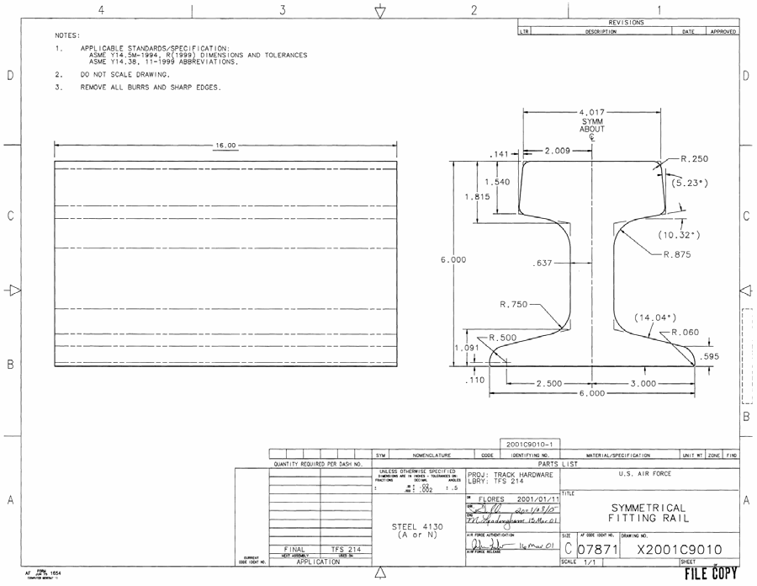

FIGURE 4.3 – Rail Geometry

* + 1. Girder. The track was constructed in five distinct sections. Figure 4.4 displays the cross section of the girder and how the design changed as the track progressed north. The fifth section at the north end, not shown, is referred to as the pulldown. Posts holding the rails to the girder in the pulldown can be adjusted/replaced to change the curvature in this section.
    2. Rail Alignment Criteria. Rail survey data are measured every 26 inches, i.e. at the tiedown fixtures and half way in-between. All surveys and alignments are based on 1) lateral position measurements taken 0.75 inches down vertically from the top surface of the rail head on the side under consideration and 2) the average of vertical position measurements taken 0.75 inches inward from the outer top corners of the rail head. With this data, the rail is aligned using the following criteria as a guide to moving the rail at the individual tiedown locations:
       1. The vertical and lateral trend lines must not have any sections with a radius of less than one million feet, i.e. the trend line can not deviate more than 1.5 inches from a moving cord over 1000 feet. This criterion acts to avoid wear on the slippers due to a long term centripetal load.
       2. The gauge (distance between rails) of A rail and B rail is aligned to 83.96 inches center- line to center-line. This gauge may vary up to +/-0.080 inches. Elevation may vary between A and B rail up to +/-0.25 inches. The gauge of B rail and C rail is aligned to 30.432 +/-0.060 inches outside edge to outside edge. Elevation may vary between B and C rail up to +/-0.060 inches. This criterion is used to maintain the proper slipper gaps on dual-rail and narrow gauge sleds. **Caution should be taken when considering the use of C rail for monorail testing because its centerline is inherently rougher than A or B rails due to the alignment procedures used.**
       3. The rail is aligned at each fixture to within +/-0.025 inches of the rail at the fixture to either side of it, both in the lateral and vertical directions, and is referred to as rail roughness. Note that the deviations can be significantly larger than this between the tiedown hardware where the rail is not constrained. Maintaining these rail roughness criteria insures the dynamic impact (Lambda) loads are adequate for design. Note that most of the rail from TS 30,000 north has been aligned to these criteria. South of this, we are in the process of refurbishing and aligning the rails to meet these criteria down to TS 5000. Also, the rail south of TS 15,000 has not been aligned to all the above criteria and should not be used for high speed missions.

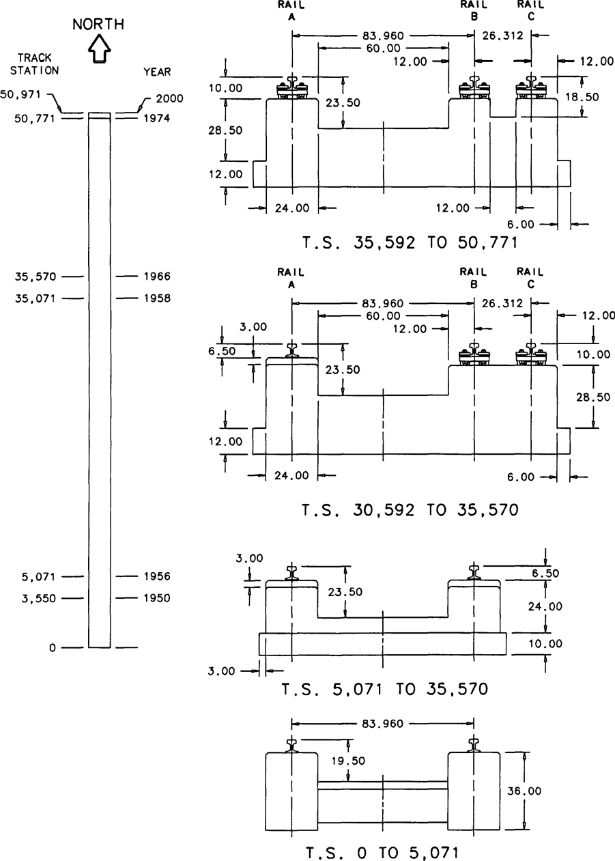

FIGURE 4.4 – Girder Cross Sections

Note: C rail between TS 30592 and TS 35570 added in 2000

* 1. CONCRETE FOOTINGS
     1. Some useful references are:

|  |  |  |
| --- | --- | --- |
| Resource | Author | Notes |
|  |  |  |
| [www.concrete.org/PUBS/pubs.htm](http://www.concrete.org/PUBS/pubs.htm) | American Concrete Institute (ACI) | ACI is acknowledged as  the authority on concrete design |
| Design of Concrete Structures | Arthur H. Nilson | Text Book used at NMSU |
| Principles of Foundation Design | Braja M. Das | Text Book used at  NMSU |
| Pulldown Girder Design for  Hypersonic Upgrade Program | Mixon Technologies  Inc. | ZZ1-115 in the  Engineering Library |

* + 1. Loads. Most of the footings designed at the track are for rail pulldowns. These must support the dynamic and quasi-steady loads from sleds. On rail pulldown footings, the loads are dominated by quasi-steady uplift. As a result, these footings have tended to have large mass to counteract the uplift. However, dynamic loads can be significant. The use of Lambda loads (Section 1.2.1.) has proven to work very well to represent the sled dynamic loads.

4.4.3.. Factor of Safety. A factor of safety (FS) for footings of 1.5 has proven adequate in past applications. This applies to all components of the footing design -- compressive stress in concrete, bearing stress in soil and tensile stress in reinforcing steel. Thus:

-- Compressive Limit Stress in Concrete x 1.5 < Concrete Strength Ordered

-- Bearing Limit Stress on Soil x 1.5 < 1500 psf or

< the Recommended Soil Bearing Stress in a Geotechnical Report

-- Tensile Limit Stress in Reinforcing Steel x 1.5 < Yield Strength

* + 1. Soil Bearing Capacity. With large footings such as pulldown footings, a reasonable design can usually be accomplished assuming low soil bearing capacity because the loads are distributed over a large area. Past experience has shown that design loads (i.e. limit load x 1.5 SF) of 1,500 psf or less have performed well. If more bearing capacity is required, a geotechnical investigation can be obtained, easily and economically, from any number of professional testing laboratories in the local area. These investigations result in a written report with the recommended soil bearing stress for design purposes. Most of the soil in our area has been shown to have a bearing capacity of 3,000 psf or higher. However, there are some localized areas with poor soil that will only support 1,500 psf.
    2. Maintain Download. If the edge of a footing is allowed to lift up, some soil will work under the footing. Repeated loadings of this type will cause the footing to “walk” out of the ground. Therefore, correct sizing of the footing is required to insure that a download exists on the soil at all times (i.e. Bearing Design Stress > 0 psf).
    3. Concrete Mix Specifications. There are two known environmental agents in the Holloman/Alamogordo area that can cause premature deterioration in concrete – sulfate attack and Alkali Silica Reaction (ASR). Both of these mechanisms cause an increase in solid volume or internal expansion that leads to cracks, movement and loss of strength. The source of the sulfate in our area is calcium sulfate (gypsum). Gypsum is soluble in water and enters concrete by capillary action. The source of ASR is some highly reactive aggregates indigenous to our area coupled with the alkali present in cement. These agents have actually caused premature concrete failure at Holloman. As a result, the 49CES now specifies special concrete mix designs to resist sulfate attack and ASR.
    4. Concrete Strength. When you order 3,000 psi concrete, you are specifying concrete that will have a minimum compressive strength of 3,000 psi. 3,000 psi concrete is the minimum grade for structural concrete. For Track purposes, 3,000 psi concrete is the minimum strength that should be specified. This strength is usually adequate for Track designs. However, 4,000 and 5,000 psi concrete has been used in many instances and can also be obtained when necessary.
    5. Cure Time. Concrete gets stronger as time passes. Concrete reaches half its specified strength in 7 days, but will not reach its full specified strength for another 21 days (28 days from the date of placement). Often times the seven day, half strength is sufficient to allow some work to begin (e.g., you could bolt the steel pulldown structures to the footing and begin aligning the rail after seven days, but you would not want to run a sled over the pulldown until the full 28 days had passed). If you order higher strength concrete than you designed for, you can shorten the required time to reach design strength (e.g., designed for 3,000 psi concrete, order 5,000 psi concrete, IOC in ten days).
    6. Materials Testing. All structural concrete should be sampled and tested by a qualified laboratory. Such labs provide a written report from a P.E. certifying the strength of the concrete material and other information such as air content and slump.
    7. Reinforcing Bar Joints. Reinforcing bar (rebar) joints are generally made by overlapping the sections of rebar a length equal to 36 bar diameters. This joint, the lap joint, is the industry standard and has been used successfully for footings at the Track. However, commercially available rebar couplings have also been employed (usually economical on large diameter bars). Butt weld joints have also been employed, but only with weld grade rebar.
    8. Anchor Bolts. Anchor bolts that are long enough to engage vertical bars in the rebar cage are recommended for Track use. Anchor bolts that rely only on the shear strength of the concrete to resist tensile loads are not recommended.
  1. SCREENBOXES
     1. Definition. Rocket motor staging and event initiation is generally accomplished electrically. The HHSTT uses a pair of screenboxes (one positively charged and one negatively charged) to initiate these events after the sled is launched. These screenboxes typically consist of

aluminum screen stretched across the opening of a steel channel. The screens are energized with 300 volts (nominally) from a battery-powered capacitor-discharge fire box connected to them.

The knifeblades from the sled cut the screen and the voltage from the fire box is transferred to initiate the appropriate event. Screenboxes and their power supplies are placed trackside at the appropriate location where the event is to occur. Drawings of screenboxes and associated hardware are filed under TFS 211.

* + 1. Backup (Redundant) Screenboxes shall be used for all motor staging and event initiations when possible.
    2. Screenbox Supports. For new test configurations, adequate support structure between the rail and the screenbox shall be designed to insure the aerodynamic loads from passing sleds will not result in screenbox movement such that the knifeblades miss cutting the screenboxes.
  1. SLED AND TEST DESIGN BEST PRACTICES
  2. CROSS-TRACK WIND LIMITS
     1. Monorail Sleds. The maximum allowable cross-track wind limits, in knots, are as follows:

|  |  |  |
| --- | --- | --- |
| Mach No. | Up to 9” Dia Monorail | Greater than 9” Dia Monorail |
| 0 - 3.0 | 10 | 7 |
| 3.0 - 5.0 | 5 | 3 |
| Above 5.0 | 3 | 3 |

Nose geometry is very important when considering wind limitations. The values listed above are for axisymmetric cantilevered payloads (e.g. biconic, multi-probes/cone, cones, hemispheres, spiked bodies, etc.). For non-axisymmetric cantilevered payloads (e.g. vertical or horizontal wedges, half-cones/wedge, pitch down angle of attack bodies, etc.), special consideration must be made with the possibility of reducing the allowable cross-track wind speed. The monorail vehicle configuration aft of the payload should also be taken into consideration. As its shape deviates from axisymmetry, allowable cross-track winds speed may need to be reduced.

Monorail vehicles without download control features (e.g. canards, bleed ports, flow diverter wedges forward of the slipper area, etc.) could require special consideration for speeds above Mach 3.0. See Reference 5.1.

* + 1. Other Sleds. Dual rail, outrigger, and narrow gage sleds generally do not have a wind limitation for structural considerations. Test requirements become the determining factor. Some large dual rail sleds such as MASE can be wind critical during handling and placing on the Track.
  1. Foams. Open- and closed-cell foams have been used for various purposes at the HHSTT. Open-cell foam is generally used for isolating instrumentation packages and components. Open- cell foam comes in various densities and can generally be cut to the appropriate shape. Closed- cell foam has been used for braking media, light weight support structures, and sled models. Closed-cell foam also comes in various densities and can be cut to shape.
  2. VELOCITY MEASUREMENTS
     1. Time and Position Systems. Sled velocity along the track may be obtained using data from a number of systems. Raw position versus time data are generally obtained by time tagging the sled passing a discrete point on the track. The time and position data are used to compute an average value of velocity from one time tag to the next by the relationship velocity = Δs/Δt. The constant velocity value within each distance interval is assigned in a tabular listing such that the value appears to correspond to the interval leading time and its corresponding TS. The following time and position systems are commonly used.
        1. Space-Position Over Time System (SPOTS). This system consists of a series of coil sensors permanently mounted to the rail web which detect ferromagnetic material in the vicinity

of the slippers as sleds pass. The coil sensor locations are defined in Table 5.1 below. The signal is transmitted through the underground cable plant, and the Timer Programmer console records timing data. System accuracy has been shown to be better than 0.1% at 6,000 feet per second (fps), or  3fps. See Reference 5.2. System accuracy is highly dependent on several factors, and is limited largely by the system absolute timing accuracy of +1 msec (not including velocity- dependent sensor rise time and delay thru the cable plant). This system has been used to measure sled velocity up to 9400 ft/sec.

Table 5.1 - SPOTS Coil Sensor Field Configuration

|  |  |  |  |
| --- | --- | --- | --- |
| **Reference** | **Track Station [feet]** | **Location Relative to Reference** | **Nominal Spacing [feet]** |
| **A-Rail** | 161 to 5,051 | West of rail | 104 |
|  | 5,257 to 48,314 |  | 208 |
|  | 48,418 to 50,498 |  | 104 |
| **B-Rail** | 161 to 5,051 | East of rail | 104 |
|  | 5,257 to 48,314 |  | 208 |
|  | 48,418 to 50,498 |  | 104 |
| **C-Rail** | 36,310 to 48,314 | East of rail | 208 |
|  | 48,417 to 50,705 |  | 104 |

* + - 1. Breakwire System. This system consists of wire, typically 30 gauge, supported on foam blocks placed on the rail head. As the wires are broken by a passing sled, timing data are recorded through the Timer Programmer console. Up to 30 wires can be fielded anywhere along the track at specified locations. Placement accuracy is generally within +1/32 inch. This system has been used to measure sled velocity up to 9400 ft/sec. Note that a large number of breakwires on high speed sled tests has caused considerable, non-catastrophic, damage to slippers as well as slipper thermal protection.
      2. RR-200 Fiber-Optic System. This system, configured entirely trackside, consists of optical fibers in special holders placed at surveyed locations. As the fibers are broken by a passing sled, timing data are recorded. Up to ten fiber-optic sensors may be fielded anywhere on the track, over approximately a 1500 ft maximum span of track. Fiber placement accuracy is generally within +1/32 inch. The system acquires absolute timing data with an accuracy of +2 microseconds. This system has been used to measure sled velocity up to 9465 ft/sec.
      3. Velocity Measuring System (VMS). This system uses a sled-borne light-based sensor triggered by trackside fixtures (interrupter blades). These permanently installed interrupter blades are installed trackside at the locations shown in the Table 5.2 below. Blade-to-blade spacing is precisely surveyed using an interferometer. A sled-borne DAS or telemetry system is used to acquire timing data. The VMS heads are installed and removed at the sled launch and stop points respectively, and must be mounted in the forward region of the leading sled, preferably clear of slipper/rail debris and sled leading edge shock systems. The head design allows for limited horizontal and vertical excursions of the slipper gap and for irregularities in rail alignment. System accuracy has been shown to be 0.004% at 1500 ft/sec, or  0.03 ft/sec.

See Reference 5.2. This system has been used to measure sled velocity up to 4000 ft/sec. Note that VMS has experienced unreliable (noisy) data in areas of the track with rail top and trough water brake media, or if the track facility is wet from precipitation.

Table 5.2 - VMS Interrupter Blade Field Configuration

|  |  |  |  |
| --- | --- | --- | --- |
| **Reference** | **Track Station [feet]** | **Location Relative to Reference** | **Nominal Spacing [feet]** |
| **A-Rail** | 35,200 to 39,575 | West of rail | 41/3 |
| **B-Rail** | 0 to 30,586 | East of rail | 41/3 |
| **C-Rail** | None | N/A | N/A |

* + 1. Photo-Optic Systems. Velocity may also be determined from photo-optic data sources such as Fixed (FX) cameras and Image Motion Compensation (IMC) cameras.

Here, velocity is determined by dividing the known size, typically length, of the object in the film by the difference in timing of the objects leading and trailing edges. Timing data are recorded on the film. IMC cameras have been used to measure sled velocity up to 9465 ft/sec. The Trajectory Information System (TIS) may serve as the primary source of trajectory data of sled and test items separating in three-dimensional space. The TIS has been used to measure sled velocity up to approximately 1400 ft/sec.

* 1. Velocity Window. The Velocity Window is a feature of the Timer/Programmer in the Track Data Center (TDC). Its purpose is to verify that the sled’s velocity is within an allowable range just prior to it reaching the screenbox that initiates the event. The Timer/Programmer accomplishes this by comparing the time the sled takes to travel between two breakwires placed on the railhead of the track. It compares this time to the acceptable range of times that the sled would take if it was traveling above the minimum velocity and below the maximum velocity. If the time is in the acceptable range, the Timer/Programmer enables the screenbox power supply to energize the screenbox and thus initiate the event. If the time is outside the acceptable range, the screenbox is left de-energized and the sled passes through with no event initiation. The Velocity Window can be placed anywhere along the track. It has been successfully used up to 1400 ft/sec.
  2. PROPULSION
     1. Motor mounting provisions shall be designed to permit loading of the motor(s) by use of an overhead crane.
     2. Motor mount(s), attachments, and sled structure shall be designed to allow for longitudinal and radial motor case expansion appropriate for the motor(s) used.
     3. Motor case(s) may be used as a structural member. However, the designer shall analyze the motor case(s) to insure that combined stress levels remain within specified limits for all operating conditions.
     4. No structure shall extend aft of the rear nozzle exit plane except for the water brake and push pad structure, if mounted on the aft beam of the sled.
     5. Forward Motor Mounting
        1. All forward motor mounting fitting(s) shall be designed to eliminate or minimize bending moments induced in the motor case(s) due to the sled structural deformation or dynamic loads during all operating conditions.
        2. The motor case(s) shall be analyzed to insure it is capable of sustaining induced moments within specified material strength margins of the motor case(s).
     6. Aft Motor Mounting. All aft motor supports shall accommodate thermal growth in motor case length appropriate to the motor(s) used.
     7. Misfire Conditions. All sleds operating with motors shall be designed to sustain, without structural damage, asymmetric loadings due to all possible misfire motor combinations.
     8. Propulsion Wiring
        1. All wiring used for motors will be routed through conduit to the maximum extent practical.
        2. Motor mount(s), attachments, and sled structure shall be designed to allow for easy access to the motor igniter and its wiring after the motor(s) have been installed.
     9. Available Motors. Table 5.3 provides a listing of the rocket motors commonly used by the HHSTT. Detailed information for each rocket motor is maintained by the propulsion manager.
  3. SLED DESIGN TIPS

|  |  |
| --- | --- |
| DO | DON’T |
| Minimize stress concentration by eliminating sharp corners | Specify tighter tolerances than are necessary |
| Use steel locknuts | Use coarse thread fasteners |
| Safety wire bolts in tapped holes | Use fiber look nuts |
|  | Use tapped holes except as last resort |
|  | Use lock washers |

TABLE 5.3 – AVAILABLE ROCKET MOTORS

|  |  |  |  |  |  |  |  |  |  |
| --- | --- | --- | --- | --- | --- | --- | --- | --- | --- |
| MOTOR | BURN TIME  SEC | THRUST  Max / Average  KIP | IMPULSE  KIP-SEC | WEIGHT (LBS) | | APPROX.  DIMENSIONS (IN) | | Thrust to Weight Ratio | Impulse to Weight Ratio |
| LOADED | EMPTY | DIA | LENGTH |
| HVAR | 0.94 | 5.4 | 5.2 | 83 | 55 | 5 | 51 | 64.6 | 62.7 |
| ZUNI 1 | 1 | 6.5 | 7.6 | 62 | 29 | 5 | 64 | 104.8 | 122.6 |
| 15KS1000 | 14 | 1.1 | 14.9 | 141 | 69 | 10.3 | 33.45 | 7.8 | 105.7 |
| LITTLE JOHN | 1.5 | 32 | 53.1 | 461 | 274 | 12.5 | 94 | 69.4 | 115.2 |
| -Adapter, Nike Case |  |  |  | 565 |  |  |  |  |  |
| GENIE 2 | 2.2 | 29.7 | 71.7 | 493 | 166 | 15 | 66.9 | 60.2 | 145.4 |
| NIKE 3 | 3.4 | 42 | 146 | 1,193 | 443 | 16 | 135 | 35.2 | 122.4 |
| IMP HONEST JOHN | 3.3 | 100 | 353.6 | 2,907 | 1,227 | 24.8 | 164.5 | 34.39 | 121.6 |
| ROADRUNNER | 1.8 | 31.6 | 62 | 356 | 102 | 9 | 101 | 88.8 | 174.2 |
| Super RR | 1.45 | 224 / 150 | 216.4 | 1114 | 250 | 16.2 | 136.5 | 136 | 194.3 |
| ASROC 4 | 3.6 | 11 | 43 | 373 | 140 | 12 | 57 | 29.4 | 115.3 |
| Terrier, MK12 | 5 | 57 | 244 | 1775 | 530 | 18 | 156 | 32.8 | 152.7 |
| Terrier, MK70 | 6 | 72.6 | 362.5 | 2140 | 530 | 18 | 156 | 32.7 | 172.9 |
| 5NS4500 | 5 | 5.4 | 23.5 | 208 | 86 | 9.5 | 54 | 26.0 | 113 |
| Pupfish | 1.7 | 29.4 | 51.9 | 325 | 109 | 9 | 75 | 90 | 159.7 |

1 ZUNI MOTOR NOT TO BE IGNITED IN DECELLERATION ENVIRONMENT. SEE PROJECT 13C, REF. 6.0. ZUNI MOTOR IS GROUNDED THRU ITS ALUMINUM CASE

2 AF DIRECTED NOT TO USE DUE TO PROPELLENT SLUMP, 4 ONSITE HAVE BEEN INSPECTED AND DEEMED SAFE

3 HEADCAP MUST BE EPOXIED IF MOTOR IS IGNITED IN ACCELERATION ENVIRONMENT. SEE MISSION 78R-A1, REF. 6.0.

4 SLED/ADAPTERS NOT YET DESIGNED

61

APPENDIX A - SIMP

0.0 See Reference A.1 for the report documenting this design procedure.

* 1. Design Procedure Using Sled Impact Parameter (SIMP) Factor

This procedure provides a method for refining the dynamic loads and the distributions of these loads around the sled structure. This technique requires the calculation of sled or slipper beam vertical stiffness and the use of the appropriate SIMP factor as follows:

* 1. Dual Rail Sleds:

In order to calculate the SIMP factor for dual rail sleds, several parameters of the sled’s design must be obtained. These are:

* + 1. Sled mass (1b  sec2 /in)
    2. The sled center of gravity referenced to the slipper beams (in)
    3. The mass moment of inertia about the center of gravity in the pitch plane (in-1b-sec 2 )
    4. Each slipper beam stiffness (lb/in)

The slipper beam stiffness is the ratio of the magnitudes of a vertical force to the vertical deflection caused by the force with the force applied at the sled lateral centerline where the sled body interfaces with the slipper beam. Once the slipper beam stiffness’ have been determined, calculate the SIMP factor for each beam using the following equations:

1

  2

 *K M* 

SIMP F =  *F* 

2

Forward Slipper Beam

 *M*𝑙 *F* 



1 

 *I* 

1

  2

 *K M* 

SIMP A =

 *A* 

Aft Slipper Beam

 *M*𝑙 2 



1 

*A*

 *I* 

Where: ***I*** is mass moment of inertia about center of gravity in pitch plane

**KF** is front slipper beam stiffness

**KA** is aft slipper beam stiffness

**𝑙F** is the distance from the front slipper beam to the sled center of gravity

**𝑙A** is the distance from the aft slipper beam to the center of gravity

***M*** is sled mass

All units are dimensioned as previously given

Once the individual SIMP factors have been calculated, the peak slipper beam dynamic loads can be found from Figure A.1. These SIMP based dynamic loads are assumed to be independent of velocity; however, for velocities below 1,200 feet per second, lower values may be used but must be approved by the TGTM Flight Chief.

In order to determine inertial loadings on the body due to the dynamic loads, use the following equations to approximate the distribution between the vertical and pitch inertias as schematically represented in Figure A.2:

*F*  *FA*

Case 1:

&*z*&1



*F* 𝑙

*F* 2

*M*

− *FA*𝑙 *A*

(in/sec2)

*F F*

2

**&**1 

*I*

(rad/sec2)

Case 2:

&*z*&2

*FF*  *F*

 2 *A*

*M*

*FF* 𝑙 *F*  *F* 𝑙

(in/sec2)

*A A*

2

**&**2 

*I*

(rad/sec2)

These inertial loads are then distributed over the sled as shown in Figure A.3. Note that because the direction of the dynamic loads may be positive or negative (up or down), four sets of Case 1 and four sets of Case 2 are calculated. That is to say, the combinations of FF and FA used to calculate the inertia terms are (+,+), (+,-), (-,+), and (-,-).

The lateral dynamics will be considered to be 60% of the vertical dynamics.

Figure A.1 - Sled Im pact Param eter vs. Dynam ic Loads

Zero to Peak Slipper Beam Dynamic Loads (kips)

45

PROPULSION THRUSTING ON- BOARD

PROPUSION NOT THRUSTING ON-BOARD

40

35

30

25

20

15

10

5

0

0 200 400 600 800 1000 1200 1400 1600 1800

Sled Im pact Param eter (dim ensionless)

64

#### FIGURE A.2 – VERTICAL AND PITCH SCHEMATIC

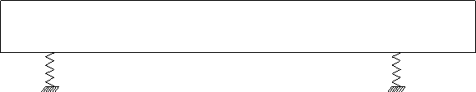

C.G.

**&**

&*z*&

M, I

KA

KF

*l*A *l*F

FA

FF

**FIGURE A.3 – DISTRUBUTION OF DYNAMIC LOADS**



FDi = -mi( *Z***&** +Xi**&** ) where i = 1,2,…,n

mn

m1

m2

Xi

C.G.

* 1. Narrow Gauge and Monorail Sleds(**NOT RECOMMENDED**):

To use the narrow gauge and monorail procedure for determining SIMP factor, the sled is idealized as a rigid body supported on springs (the slippers and support structure).

Step 1:

Estimate the following parameters of the sled from the preliminary design stage: Sled Mass (1b  sec2 /in)

Distance from sled center of gravity to the forward and aft slippers, 𝑙a 𝑙f

respectively (in)

Pitch mass moment of inertia, Ip (in-lb-sec 2)

Vertical stiffness of slippers and associated support structure, Ka, Kf (lb/in)

The slipper vertical stiffness is defined as the ratio of the magnitudes of a vertical force to the vertical deflection caused by the force as shown in Figure A.4. A word of caution is in order here. Careful judgment should be used in determining the location of the force to cause the deflection of the sled. Unlike dual rail sleds which can be isolated as a rigid body mass (main sled body) and the spring-like slipper beams, the monorail has a main body stiffness which is typically on the order of the associated slipper support structure. Due to this, significant flexibilities in the slipper support structure and the main sled body should be included in the stiffness calculations. By ignoring the flexibility of the sled body, a conservative estimate of the dynamic loads will result.

#### FIGURE A.4 – VERTICAL STIFFNESS



FV

Step 2:

Now that the stiffness has been calculated, values of the sled effective mass must be calculated that apply to each of the stiffness parameters. This results in a mass term related to both the forward and aft slippers impacting in the vertical directions. This results in the following equations defining the effective mass distributions:

*MeffF*

 *M*

1 *M*𝑙 *F*

2

###### Meff A

*IP*

 *M*

2

1  *M*𝑙 *A*

*I P*

Where the effective mass terms are in units of lb-sec2/in.

Step 3:

Now calculate the effective frequency that will occur at impact as follows:

*f F* 

1 *KF*

2 *Meff F*

*f A* 

1 *K A*

2 *Meff A*

Where all frequency terms are in the units of Hertz (Hz). Step 4:

Determine the lift-to-weight (L/W) ratios that are to be assigned to each slipper for expected critical points in the trajectory. Reference Figure A.5 for proper methodology.

Step 5:

Once the L/W distribution has been determined, enter Figure A.6 for the appropriate value of sled forward velocity V, to determine the sleds design impact velocity ( *v* ) based on its appropriate effective impact frequency. For a forward velocity not given by the curves, linearly interpolate between the two nearest given velocities. Forward velocities exceeding that shown in Figure A.6 have not been characterized and should not be considered for the SIMP design procedure.

Step 6:

Once the impact velocity has been found, compute the maximum slipper dynamic loads by the following:

*FF*  2

*f F vF Meff F*

(lb)

*FA*  2

*f A vA*

*Meff A*

(lb)

Step 7:

In order to determine inertial loadings on the body due to the dynamic loads, use the following equations to approximate the distribution between the vertical and pitch inertias as schematically represented in Figure 2:

Case 1:

&*z*&1 

*F*  *FA*

*F* 2

*M*

(in/sec2)

**&**1 

*FF* 𝑙 *F*

− *FA*𝑙 *A*

2

*I*

(rad/sec2)

*FF*  *F*

*A*

Case 2:

&*z*&2

 2

*M*

(in/sec2)

*FF* 𝑙 *F*  *F* 𝑙

*A A*

2

**&**2 

*I*

(rad/sec2)

These inertial loads are then distributed over the sled as shown in Figure A.3. Note that because the direction of the dynamic loads may be positive or negative (up or down), four sets of Case 1 and four sets of Case 2 are calculated. That is to say, the combinations of FF and FA used to calculate the inertia terms are (+,+), (+,-), (-,+), and (-,-).

The lateral dynamics will be considered to be 60% of the vertical dynamics.

FIGURE A.5 – DISTRIBUTION OF SLED LIFT AND WEIGHT FORCE



*l*A

*l*F

W

WA

WF

L

*l*LA

*l*LF

LA

LF

CENTER OF LIFT

CENTER OF GRAVITY

LA/WA = (*l*LF**/***l*F) * (L**/**W) LF/WF = (*l*LA**/***l*A) * (L**/**W)

For negative values of the lift-to-weight ratio use the value: |L/W| - 1

# Figure A.6 - Impact Velocity

**Impact Velocity, V (in/sec)**

90



Sled Velocity, V = 2000 ft/sec

L/W = 0,1

10

25

50

80

70

60

50

40

30

20

10

0

0 50 100 150 200 250 300 350 400

**Effective Impact Frequency, f (Hz)**

# Figure A.6 - Continued

**Impact Velocity, v (in/sec)**

90



Sled Velocity, V = 4000 ft/sec

L/W=0

10

25

50

80

70

60

50

40

30

20

10

0

0 50 100 150 200 250 300 350 400

**Effective Impact Frequency, f (Hz)**

# Figure A.6 - Continued

**Impact Velocity, v (in/sec)**

90



Sled Velocity, V = 6,000 ft/sec

L/W = 0

10

25

50

80

70

60

50

40

30

20

10

0

0 50 100 150 200 250 300 350

**Effective Impact Frequency, f (Hz)**

APPENDIX B – ACRONYMS

ARC Building – Antenna Relay Center ASLED – Slipper Load Analysis (software) AXUM – Data Analysis/Processing (software) CdA – coefficient of drag times area

CDA – Drag Coefficient (software) CDR – critical design review

CFR – concept feasibility review CG – center of gravity

DADS – Dynamic Analysis & Design System (software)

DAS – data acquisition system DBA – direct budget authority

FM/FM – Frequency Modulation/Frequency Modulation

GT - general time He (helium)

HTS – Horizontal Test Stand ICS – Initial Contact Summary

IDAM – Inverse Dual Rail Water Braking Profile (software program)

IDEAS – Design, Analysis, Drafting & Manufacturing software

IMC – image motion compensation

IRIG – Inter-Range Instrumentation Group JOCAS – Job Order Cost Accounting System JON – Job Order Number

KEAS – knots equivalent airspeed L-day – launch day

MRBRK – Monorail Braking (software) NDI – non-destructive inspection

NewTec – New Mexico Technology Group NGB – Narrow Gauge Braking (software) OPlan – operations plan

PCM/FM - Pulse Code Modulation/Frequency Modulation

P-switch - persistence switch

PDR – Preliminary Design Review PID – Project Introduction Document RBA – reimbursable budget authority

SCANDEX – electronic drawing storage system SIMP – Sled Impact Parameter (software)

SOC – Statement of Capability

SPOTS – sled-position over time system

T-Time – sled launch time or event initiation time

TIS – Trajectory Instrumentation System TM – telemetry, or test manager

TDC – Track Data Center

TRAJ – Ballistic Trajectory (software) TSLED – Sled Trajectory (software) TSPI – time-space position information VMS – velocity measuring system WBS – Work Breakdown Structure

WDAM – Dual Rail Water Dam (software)

APPENDIX B - SPELLING

birdchaser blockhouse boneyard breadboard breakfiber brakesetter breakstick breakwire buildup (n) checkout (n) cooldown (n) crosstrack (n) crosswind (n) cryo-pad downtrack dual rail

fail-safe

feet/foot per second, ft/sec, ft/s, fps feet-per-second squared

flyout (n) forebody free-flight

g, g’s (acceleration of gravity)

gauge (narrow gauge, don’t use gage) greenhouse

guide rail guideway hall probe hangfire (n) headcap hypersonic

igniter, ignitor in-house initiator kickoff, (n, adj)

kilometers per second, km/sec, km/s knifeblade

maglev manikin milkstool misfire monorail nosecone

off line, off-the-line offset

onboard payload

photo-optic

post test, post-test, posttest prelaunch

pretest Pupfish push pad quick-look pull away

pulldown (n) Reagen Draw rail gouge rainfield Roadrunner sandbag screenbox simulant (n) simulate (v)

sled borne, sled-borne subsonic

supersonic trackside

Tula Peak, Tularosa Peak video-optic

water dam

**APPENDIX C – STANDARD HARDWARE**

|  |  |  |  |  |  |  |  |
| --- | --- | --- | --- | --- | --- | --- | --- |
| **Item Name, Drwg. #** | | **Limit Load (kips)** | | **Recorded Load (kips)** | | **Notes** | **TGTM Library Reference** |
|  | | **Compres.** | **Tens.** | **Compres.** | **Tens.** |  |  |
| Standard Aluminum Coleman  Coupling, 66D2277 | | 110 | 110 | 110 | 110 | Uses 170 ksi Trunnion | PA-02 |
| Heavy Duty Alum. Coupling,  71F18402 | | 383 | 123 | 254 |  | Tens. Limit 1.5” dia. NAS Trunnion  Bolt | PA-01 |
| Heavy Duty B-1 Alum. Coupling,  2002E37809(L9531387) | | 606 | 114 | 254 |  | Tens. Limit 4 each ¾” dia. NAS  Attach. Bolts | TBD |
| Instrumented Coupling Bolt,  82C4652 | | 279 | 136 | 325 | 100 |  | CBI-01 |
| Mono Ball Coupling, TMR-33-D13 | | 765 | 655 | 492 | 49 | Recorded on Ballast Fbdy.  Tens. Limit 8-1¼” dia. NAS Attach.  Bolts | MC-04 |
| Push Column 16in dia. Alum.,  71E18270-50 | | 130 | 130 | 75 |  | 15.3 Ft. Long | TFS-241 |
| Push Column 16in dia. Alum., 82E4471 | | 276 | 114 | 254 |  | 18 Ft. Long  Tens. Limit by Heavy Duty B-1 Alum. Coupling |  |
| ** CAUTION – FOLLOWING BOGIE BEAM RATINGS ARE FOR REFERENCE ONLY ** | | | | | | | |
|  | Vertical | | Lat. | Meas.Vert. |  |  |  |
| Talos Pusher (FDN 8209),  71E18631 | 44.5 | | 35.5 |  |  |  |  |
| IDS 6412-2, 12FTK3120 | 55.2 | | 43.1 |  |  |  |  |
| B-1 (FDN 7207), L9531397 | 87 | | 12 * |  |  | * Insufficient stress analysis  available |  |
| Ballast Fbdy. (FDN 8701),  90E6118 | 52 | | 62 |  |  |  |  |
| MASE (FDN 8505), 52197-D9.2 | 57.3 | | 38 | 32 |  | Measured data clipped |  |

**WEIGHT (LBS)**

**APPENDIX D – DEMONSTRATED CAPABILITY**

The following figure shows the envelop of demonstrated capability for some of the rocket sled vehicles used in the past. It should be noted that the RAMJET sled has only been checked out to approximately 3000 ft/sec. See mission 23D-B1, Ref. 6.0. Also note recoverable velocity is currently limited to 7500 ft/sec.



**PERFORMANCE ENVELOPE**

**MISSION SLED GROSS WEIGHT VS VELOCITY**

100000

10000

B-1

LLDS

ARROWHEAD RAMJET

SM-2 WH

1000

LANCE

NNK

(RECOVERED)

NNK

(IMPACT)

HUP

100

CHAPARRAL

ZAP

HIF

10

1

0

2000

4000

6000

8000

10000

**VELOCITY (FT/SEC)**

#### APPENDIX E – CLIMATOLOGY

**STATION PRESSURE**

0.970

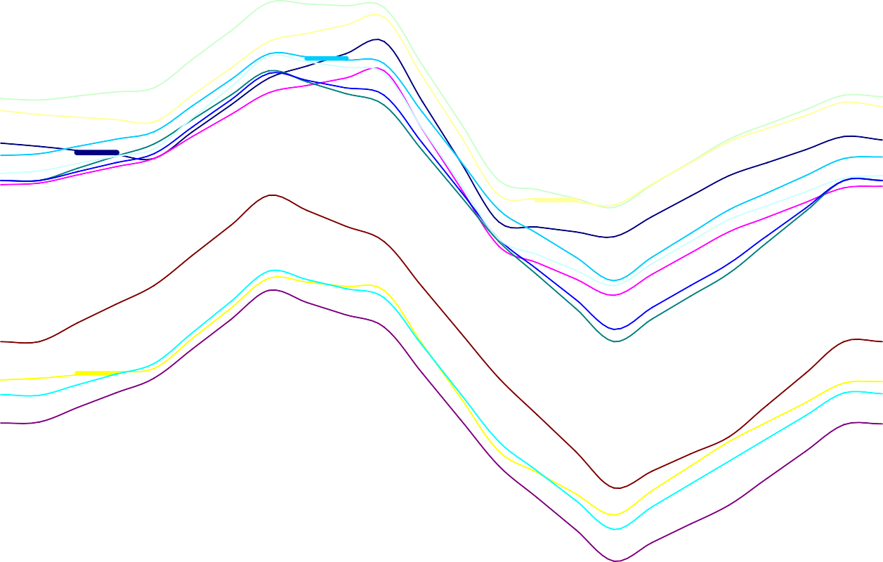

Nov

Dec

Jan

Oct

Jun

Apr

Sep

Feb

Aug

Jul

Mar

May

0.960

0.950

0.940

0.930

Jan Feb Mar Apr May Jun Jul Aug Sep Oct Nov

Dec

0.920

0.910

0.900

**MEAN PRESSURE (INCH Hg)**

**(ADD 25" to Chart Value)**

0.890

0.880

0.870

0.860

0.850

0.840

0.830

0.820

0.810

0.800

0.790

0.780

0.770

0.760

0.750

0.740

0.730

0.720

0.710

0.700

**TIME (HRS)**

0100

0200

0300

0400

0500

0600

0700

0800

0900

1000

1100

1200

1300

1400

1500

1600

1700

1800

1900

2000

2100

2200

2300

2400

**MEAN TEMPERATURE**

100

95

90

85

80

**MEAN TEMP (DEG F)**

75

Aug

Jun

70 Jul

65

Sep

60

55 May

50

Feb Dec

Jan

Apr Oct

Mar

Jan Feb Mar Apr May Jun Jul Aug Sep Oct Nov

Dec

45

40 Nov

35

30

0100 0200 0300 0400 0500 0600 0700 0800 0900 1000 1100 1200 1300 1400 1500 1600 1700 1800 1900 2000 2100 2200 2300 2400

**TIME (HRS)**

REFERENCES

NOTE: Track Engineering Library (TEL) is Reference 6.0

* 1. Myers, Jack, *Aerodynamic Analysis of the Hypersonic Narrow Gage Sled (Over/Under Concept)*, 21 April 1999. (TEL ZZ1-116)
  2. Stickford, Saunders, Hesse, Sullivan, Colley, Tucker, *Pressure and Temperature Predictions During High Speed Sled-Track Tests*. (TEL B-303)
  3. Praharaj and Roger, *Aerodynamic Computations of Integrated Missile on Sled Vehicles*, AIAA Paper 96-0290, 1996. (TEL B-304)
  4. Minkiewicz, Bosmajian, *Effects of Supersonic Bounded Flow on a Modified Double Wedge Airfoil*, AIAA Paper 96-0561, 1996. (TEL B-305)
  5. Lofthouse, Hughson, Palazotto, *Hypersonic Test Sled External Flow Field Investigation Using Computational Fluid Dynamics*, AIAA Paper 2002-0306, 2002. (TEL B-306)
  6. Aircraft Armaments Inc., *Ground Interference Effects on Rocket Sleds*, Apr 1961. (TEL B- 31)
  7. Mills, Robert Jr., Comparison of Experimental and Theoretical Pressure Distrubution Caused by Ground Interference Effects on Horizontal Wedge Test Track Sleds, NAVWEPS Report 7564, 1960. (TEL B-175)
  8. Shigley, Joseph E., *Mechanical Engineering Design*, Third Edition
  9. Ohio State University Research Foundation, *Study of Track Failure Criteria*, April 1966. (TEL AA-202)
  10. Ohio State University Research Foundation, *Study of Track Failure Criteria*, April 1967. (TEL AA-28)
  11. Wolson, Milton R., *Wear, Solid Lubrication and Bearing Material Investigations for High Speed Track Applications*, AFMDC-TR-60-7, March 1960. (TEL DD-202)
  12. AZ Technology, Inc. (Schmitz, Craig P.), *Slipper Wear/Gouging Analytical Tool, SBIR Phase II Final Scientific and Technical Report*, August 2000. (TEL DD-84)
  13. Mil-HDBK-5, Military Standardization Handbook-Metallic materials and Elements for Aerospace Vehicle Structures, Latest Edition.
  14. Bickford, John H, *An Introduction to the Design and Behavior of Bolted Joints*, 1981.
  15. T.O. 1-1A-9, Aerospace Metals – General Data and Usage Factors, Latest Edition.
  16. Krupovage, Daniel J., et al, *Monorail Rocket Sled Braking at Supersonic Speeds*, 40th Meeting of the Aeroballistic Range Association, Paris France, September 1989. (TEL D- 77)
  17. Krupovage, Daniel J., *Rail Friction and Slipper Wear on the Holloman High Speed Test Track*, 38th Meeting of the Aeroballistic Range Association, Tokyo, Japan, October 1987. (TEL DD-63)
  18. Rassmussen, Hans J., *Rocket Sled Velocity Measuring Techniques*. (TEL BB-81)

6.0. Track Engineering Library (TEL)

A.1. Greenbaum, Gilbert A., Garner, Terry N., and Platus, David L., *Development of Sled Structural Design Procedures*, AFSWC-TR-73-22, March 1974. (TEL E-102)

**INDEX**

**A**

ACRONYMS, 72

Adhesives, 39

Aerodynamic Deflection, 22

AERODYNAMIC HEATING PROTECTION, 43

Allowable Stress, 20 Application of Loads, 14

**J**

Jacking Gear, 40

##### K

KNIFEBLADES DESIGN, 46

##### B

Brake Design, 46

Brake Operation, 46

Braking Loads, 11

##### C

**CLIMATOLOGY**, 76

CONCRETE FOOTINGS, 54

Critical Lifts, 40

CROSS-TRACK WIND LIMITS, 57

##### D

**DEMONSTRATED CAPABILITY**, 75

Design Loads on Slippers, 35 Drag Loads, 10

Dynamic Loads. *See* Lambda Loads, SIMP Loads

##### E

Electrical Conduit, 45

Equipment Mounts, 45

**L**

Lambda Loads, 12

Lift (and Side) Loads, 9 Lifting lugs, 39

Limit Stress, 20

##### M

Margin of safety (MS), 20 Mechanically Fastened Joints, 37 MONORAIL SLED ROLL, 23

##### N

Natural Frequency Requirements, 22

##### P

PROPULSION, 59

PROPULSION HARDWARE, 44

Pulldown Loads, 11

##### Q

QSS Loads, 9

##### F

**Fatigue**, 22

Foams, 57

Friction, 39

##### G

Girder, 51 Gouging

Slipper, 35

##### H

HELIUM BAGS, 48

Hoisting Gear, 40

##### I

INSTRUMENTATION, 50

##### R

Rail, 51

Rail Alignment Criteria, 52 Rail Friction, 11

**REFERENCES**, 78

ROCKET MOTOR BLAST ON PUSHER SLEDS, 40

Rocket Motor Ejecta Protection, 43

##### S

Safety Factor, 20

SCREENBOXES, 55

Shims, 39

SIMP Loads, 12

**SLED DESIGN TIPS**, 60

Slipper Clearance Around Track Hardware, 31 Slipper Gaps, 31

Slipper Inserts, 33

Slipper Wear, 33

SPELLING, 73

**STANDARD HARDWARE**, 74

##### T

Threaded lifting eyes, 40 Thrust (T), 9

Towing and Transportation Gear, 40 TRACK STRENGTH, 23

Transmitted Thrust (TT), 9

**V**

VELOCITY MEASUREMENTS, 57

Velocity Window, 59

##### W

Welds, 39